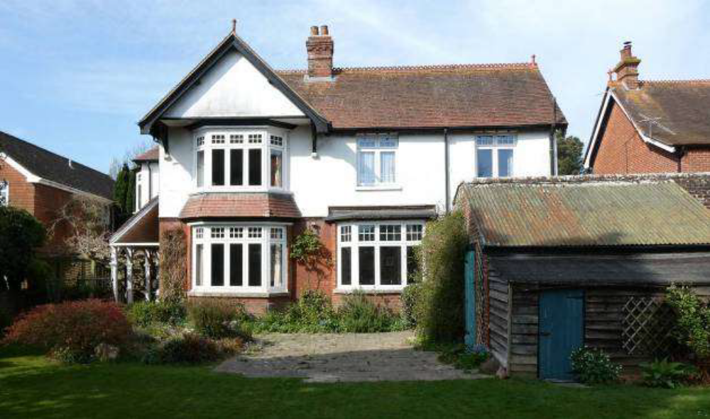
Rear of Property(above)
2.7m
Rear of Property(below)
2.3m
Extension
