Hayling Padel Ltd Flood Risk Assessment and Flood management and evacuation procedure.
Flood risk assessment.
The majority of the actual site including all the courts parking and facilities do not fall in a current flood risk area, however the access road to the site is. (see below)
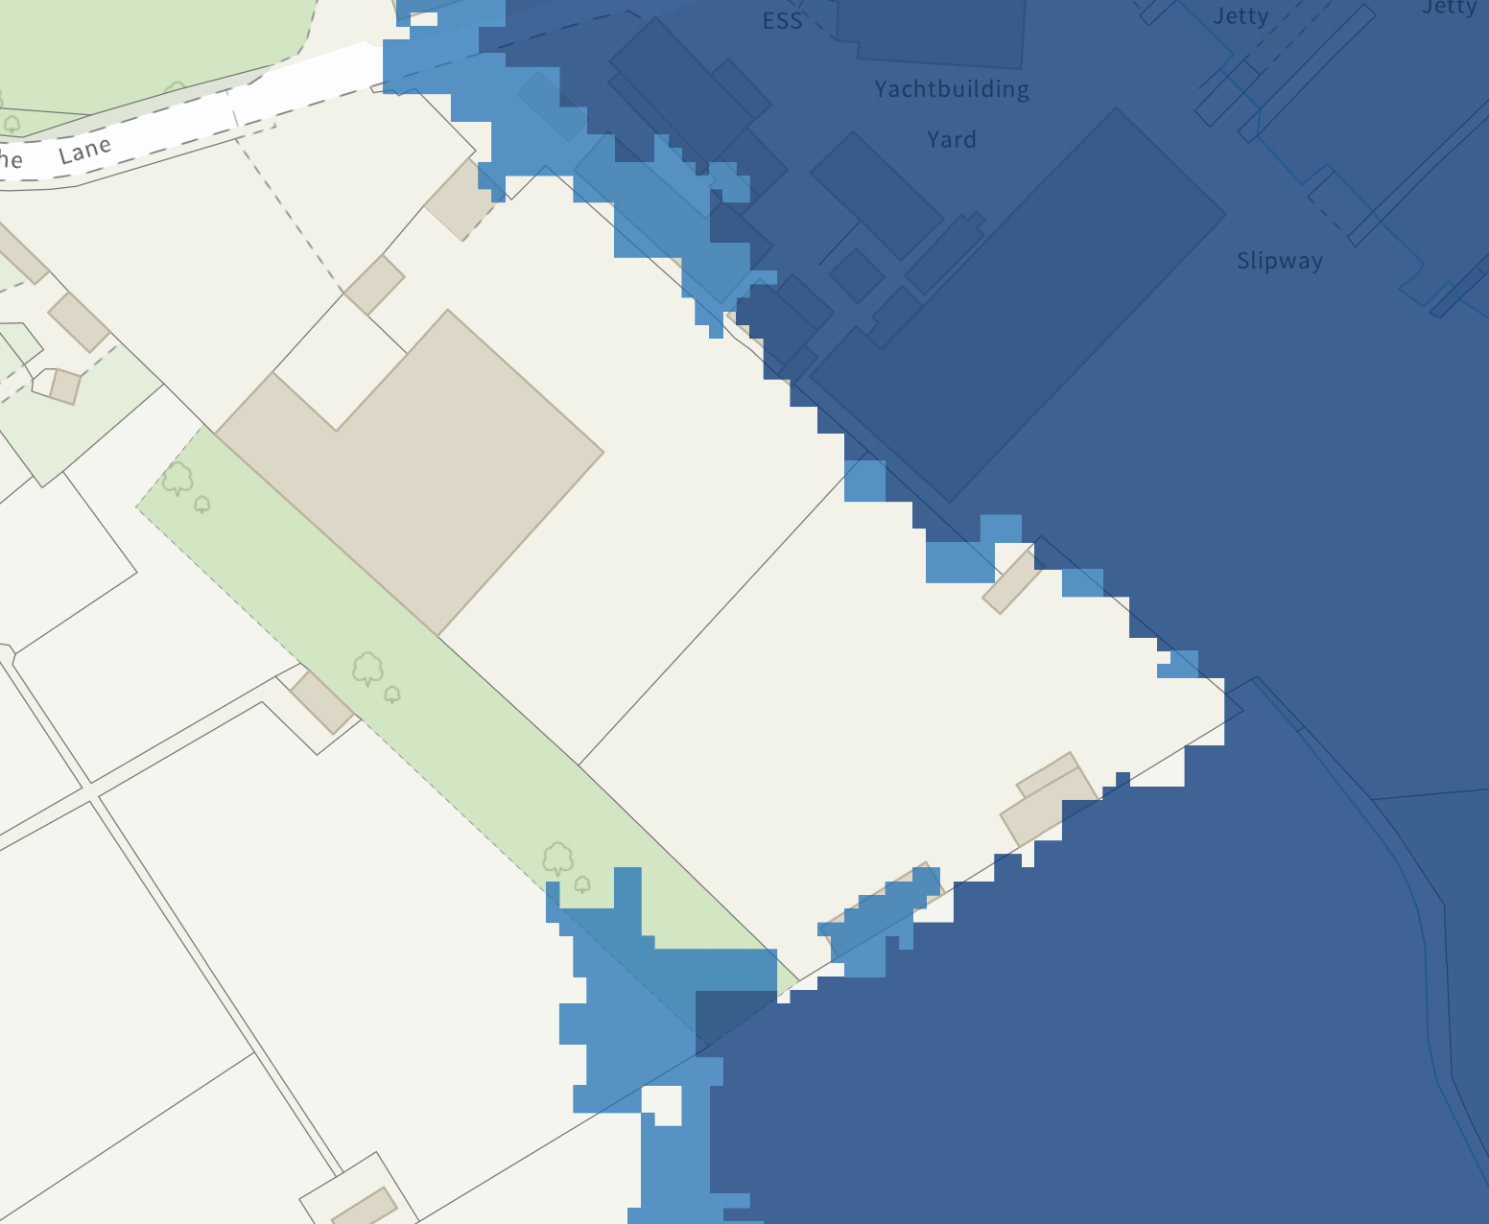
The flood risk is also completely related to tidal flooding at times of high tide in conjunction with specific weather conditions.
The structure has been designed with this in mind, all construction and courts are flood resilient and lighting is installed several meters above ground level. Welfare facilities are set 500mm above ground level to provide additional protection and are designed with plugs and switches at 1m above floor level. In addition, all power will be turned off at times of risk.
Due to the predictable tidal nature of the flood risk, we propose a flood management and evacuation plan to ensure no one is on site in periods of high flood risk. This is provided below.
Flood management and evacuation procedure
1. Introduction
The site does not fall in a flood zone however the access route to the site does fall in a zone three flood risk area with risk of flooding from the sea at seasonal high tides combined with poor weather conditions. We therefore operate a flood management and evacuation plan at all times of increased risk.
2. Why this be important to us
The Duty of Care
As a site owner / operator we are aware of our duty of care to take all reasonable steps to ensure the safety of all people on our site – visitors, residents and staff. Emergencies can happen – if and when they do our customers may need to evacuate the site safely and rapidly. An evacuation plan helps us do this.
3. Flood guidance
At all times a flood status board will be displayed at the entrance to the welfare facilities on the site,
Please take note of this status at all times.
The site will close at times of high risk however should (for any reason) the flood status board be high and the site is still open, a flood warden will be on duty continually monitoring the flood risk throughout the period of high risk.
Should the risk be considered to put the site access in danger of flooding the flood risk evacuation procedure will be followed.
4. Flood risk evacuation procedure
In the unlikely case that the flood risk evacuation procedures put in place you will hear a flood alarm sound and the flood warden will ask you to leave the site immediately. In extreme emergency he/she will ask you to gather at the welfare facility (which is outside the flood risk area) and wait till the flood risk passes.
Due to the nature of the tidal flood risk at our site this is highly unlikely and in reality, you are more likely to be asked well in advance to leave the site so it can close during the period of high flood risk.
He will instruct you to drive or walk to a place of safety away from the flood risk area and wait for the risk to clear. Due to the nature of our site this will take one to two hours to pass the point of high tide and for the flood risk to abate. Assuming the site has not flooded you will then be contacted via your contact details and made aware that the site is safe for you to return.
Staff Only
The role of the Flood Warden
Hayling Padel Ltd takes overall responsibility as the flood warden and is responsible for training the Flood Wardens to be available as required. He or she will have the
overall responsibility for the evacuation plan and will ensure that:
- The appropriate, workable plan is in place.
- It is part of the induction process for new flood wardens.
- It is regularly exercised.
- It is regularly maintained, reviewed and kept up to date.
Hayling Padel Ltd should ensure the site map and plan is on show at all times and that the flood risk boards are updated
Post warnings on the flood board of any potential high risk flood tide times.
Provide the Floodline number and quick dial code for your area so visitors can check for themselves - Telephone: 0345 988 1188; Telephone: 0845 988 1188 (24-hour service)
The overall aim of the evacuation plan is to minimise risk to life and maintain public safety. For this reason, we will always aim to have visitors and staff off your site well before the incursion of any flood water. Making sure that the agreed trigger point to start the evacuation is followed is an important part of this reassurance.
As per training the trigger for the high status is the flood warnings from the Environment Agency at this point where possible, all customers should be notified of the risk and asked to leave the site.
Once the site is clear, turn off power and water supply.
Players who refuse to leave
For many reasons a small minority of players may refuse to leave when you trigger the evacuation. If this is the case these customers must be issued with a risk to life warning and the police/emergency services must be notified.
Maintaining the plan
Your plan needs to be reviewed regularly to ensure that is still relevant to your site:
- Update contact lists and details, website links etc.
- Include changes to the site that may impact the plan e.g. layout changes;
- Add any changes as a result of exercises or events.

