Construction Method Statement

81c London Road, Waterlooville, PO7 7EL

Document Control
Document: Construction Method Statement
Status: Final
Issue: Revision 1
Prepared by: Raimond Poikans
Date: 04 June 2026

CONTENTS
1.0 INTRODUCTION
1.1 Brief
1.2 Legal Compliance
1.3 Complaint
2.0 CONTROL OF THE CONSTRUCTION PROCESS
2.1 Roles and Responsibilities
2.2 Considerate Constructors Scheme
2.3 Health and Safety Management
3.0 SITE OPERATION
3.1 Proposed Development
3.2 Access Arrangement
3.3 Parking of Site and Staff Vehicles
3.4 Laydown and Storage
3.5 Provision of Washing Facility
3.6 Road Sweeper
4.0 CONSTRUCTION METHOD STATEMENT
4.1 Introduction
4.2 Vehicle Routing Plan
4.3 Site Access and Security
4.4 Lighting Arrangements
4.5 Programme of Works
4.6 Traffic Management
4.7 Traffic Management Principles
4.8 Documentation
4.9 Demolition Sequence
4.10 Construction Sequence
4.11 Neighbour Management

5.0 ENVIRONMENTAL MANAGEMENT AND MITIGATION MEASURES
5.1 General
5.2 Dust
5.3 Mud and Debris
5.4 Odour
5.5 Noise
5.6 Pests
5.7 Litter
5.8 Asbestos
5.9 Vibration

- INTRODUCTION
1.1Brief
1.1.1 This Construction Method Plan (CMS) has been prepared in support of the planning application associated with the redevelopment/demolition of the existing buildings at 81c London Road. This redevelopment requires demolition of the existing structures and involves the creation of a two blocks of flats with parking, cycle stores, bin stores and retail store. The main demolition process is sequenced to clear the site of existing building structures.
1.1.2 The proposal consists of a: ‘Full planning application for site clearance and a new retail facility.
1.1.3 Figure
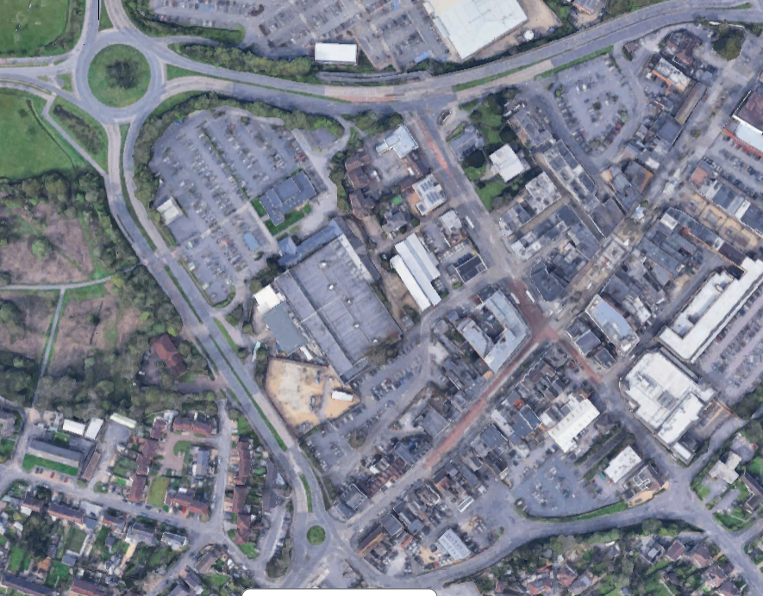
1.1 illustrates the site location.
1.1.4 The purpose of the CMS is to demonstrate the arrangements that are to be set in place for the management of construction traffic, access and safety on site throughout the construction phase of the project.
1.1.5 The CMS provides details of environmental mitigation measures to be employed at the site, along with details for traffic management relating to the construction process. Any required alterations to the details contained within the CMS will be communicated to the Construction Team.
1.1.6 The CMS provides information on the planned HGV routes to the construction site and the associated traffic management proposals required to ensure the existing public road infrastructure is maintained in an acceptable condition.
1.1.7 This document is also intended to provide clear guidance to all staff, site users and material suppliers regarding access routes to the site, maintenance requirements for the existing public road and restrictions to vehicle access.
1.2 Legal Compliance
1.2.1 Prior to commencing on site, all relevant legislation, including requirements for licenses, and/or consents shall be identified, and confirmation of full compliance obtained and kept on site. The following environmental legislation is applicable to the site.
Legislation Reference
Environment Act 1995 General
Environmental Protection Act 1990 General
Water Resources Act 1991 General
Control of Pollution (Oil Storage) Regulations 2001 General
Health and Safety Work Act 1974 General
The Control of Pollution Act 1974 General
Conservation Regulations (1994) General
The Wildlife and Countryside Act 1981 s.1
Control of Pollution (Amendment) Act 1989 General
COSHH Regulations 2002 General
Waste (England and Wales) Regulations 2011 General
Noise Act 1996 General
Control of Pollution Act (1974) s31
1.3 Complaints
1.3.1 The provision of a laminated poster will be positioned on the perimeter fence and gates; this provision will highlight the contact details of both the site manager and the contracts manager. To assist this, we have also provided a site post box in the event of any complaints being directed to the contract at hand.

2.0 CONTROL OF THE CONSTRUCTION PROCESS
2.1 Roles and Responsibilities
2.1.1 It is the responsibility of the on-site manager to ensure that a copy of the Construction Method Statement is always held at the Contractors administration office and that all the site operatives (including sub-contractors) are fully aware of the requirements set out within the document.
2.1.2 The CMS is to be reviewed by the site manager every week and any changes to procedures, accidents, incidents or non-compliance recorded by way of an addendum / diary.
2.1.3 The Local Planning Authority and Environment Agency (if relevant) will be notified as soon as possible following the detection of:
• Any malfunction, breakdown or failure of equipment or techniques, accident or emission of a substance not controlled by an emission limit which has caused, is causing or may cause significant pollution.
• any significant adverse environmental effects.
2.1.4 Written confirmation of actual or potential pollution incidents and breaches of emission limited shall be submitted within 24 hours.
2.1.5 In the event of a reportable environmental incident the site manager will be responsible for recording and reporting the event to the Local Planning Authority and Environment Agency. Environmental incidents will be recorded in the site diary.
Principal Contractor
2.1.6 For the development works the Principal Contractor/ B&M Clark will use its own direct resources supplemented by the appointment of external specialist consultants and subcontractors. The CMS will be implemented through contractual arrangements with its Sub-contractors.
2.1.7 The B&M Clark will hold overall responsibility for the implementation of the CMS and oversee any environmental issues.
2.1.8 The Site Manager will be an employee of the B&M Clark. The role of the Site Manager will be to:
• Verify that Contractor and Subcontractors have allocated sufficient resources to allow delivery of the CMS.
• Participate in communication with the Local Planning Authority (LPA) and other third parties as required.
• Regularly review the findings of the monitoring programme or those delegates with environmental responsibility.
• Arrange for periodic review and update of the CMS.
• Provide specific responsibilities for those who will be employed on the scheme.
2.2.1 In order to ensure and monitor a high standard of good practice the B&M Clark will sign up to the Considerate Constructors Scheme (an independent third- party monitor) and will adhere to the schemes code of practice. The scheme is voluntary and represents best practice in the industry. The aim of the code of practice is to.
• Minimise any disturbance or negative impact for example noise, dirt and inconvenience sometimes caused by construction sites to the immediate neighbourhood.
• Eradicate offensive behaviour and language from construction sites and to be courteous to the public.
• Recognise and reward the contractor’s commitment to raise standards of site management, safety, and environmental awareness beyond statutory duties.
2.2.2 The scheme sets out a code of practice against which the site performance is monitored by an independent Monitor under the scheme. The Code of Practice is summarized below:
• Considerate Good Neighbour Responsible.
• Environment Respect Accountable.
• Cleanliness Safe.
2.3 Health and Safety Management
2.3.1 The B&M Clark must be committed to promoting a positive safety culture.
2.3.2 The Health and Safety of the local community and all personnel involved in the project is of the highest importance. Specific risk assessments and supplementary method statements will be produced and developed by the B&M Clark, as appropriate, prior to the onset of the works.
2.3.3 The enforcing authority for Health & Safety on construction sites is the Health & Safety Executive who will be notified of this project which is a legal obligation. The site will also be managed in full compliance with the current Construction Design and Management Regulations (CDM).
2.4 Management of Unforeseen Incidents
2.4.1 The site manager will be responsible for ensuring suitable controls are always applied. The site manager will liaise with the Planning Authority and Environment Agency during the works as necessary and will ensure that, in the unlikely event of any nuisance-related issues, they are dealt with effectively and promptly.
2.4.2 In the event of a complaint or evidence of pollution of controlled waters, the Contractor will review the incident as follows:
• the cause will be immediately investigated.
• relevant operations will be suspended.
• corrective measures will be applied, and relevant operations will recommence.
• if corrective measures are not effective, the relevant operations will be suspended, and further controls applied; and
• actions undertaken will be recorded in the Site Diary.

3.0 SITE OPERATION
3.1 Proposed Development
3.1.1 The development proposal includes the demolition process of the site buildings.
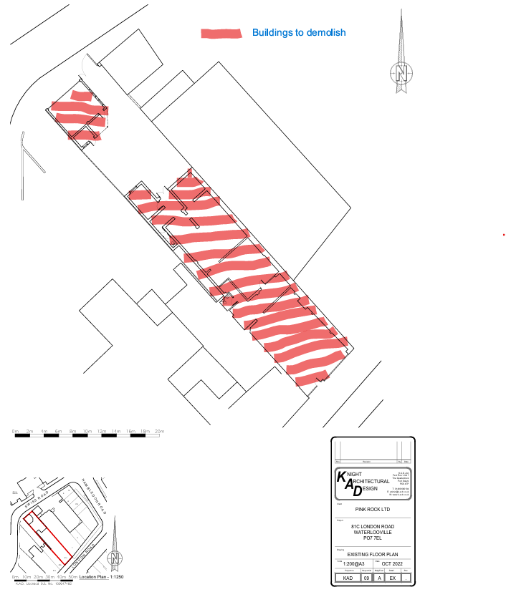

3.2 Access Arrangement
3.2.1 During construction, access to the site for construction vehicles will be via the existing Swiss Road site entrance. This will be maintained throughout the works.
3.2.2 A pedestrian plan will be provided which will be communicated and displayed to mitigate disturbance on site. The phasing plan will demonstrate when alternative routes are provided, in all instances supporting signage will be displayed.
3.2.3 Separate vehicle/ plant and pedestrian access and egress will be provided to the works area to create segregation of persons and vehicles.
3.3 Parking of Site
3.3.1 The site compound area is shown on site layout.

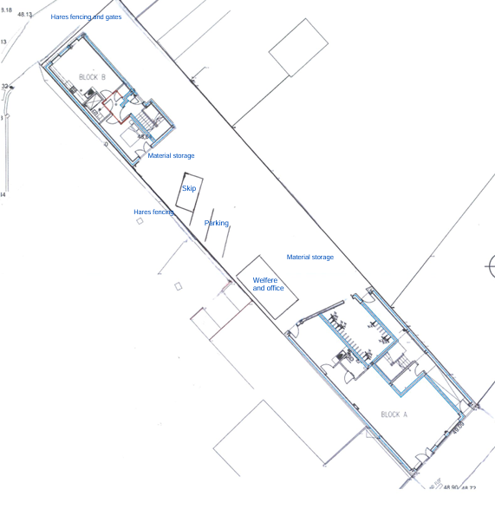
3.3.2 A compound area is proposed within the site with an office, wheel washing facilities, storage and car parking area.
3.3.3 The car park will be used by operatives. There will be no permitted offsite parking along the main road.
3.3.4 Existing supply of power and water will be used on site and will form part of the compound location and set-up proposal.
3.4 Laydown and Storage
3.4.1 Space will be allocated for laydown & storage of construction materials within proximity to the building to avoid multiple handling and travel distances. These areas are shown on the site layout drawings which will be displayed in the site offices and discussed in each induction.
3.4.2 All contractors will be assigned specific locations for their equipment, and the site will introduce a strict just in time policy to optimise the space. At no time will materials be stored or laydown in external or unauthorised areas.
3.4.3 All laydown and storage areas will be suitably signed off identifying the following:
• Project name.
• Contract Name and Number (B&M Clark).
• Contractor’s Name and Number; and
• Duration of the Project, start and end date.
3.5 Provision of washing facility
3.5.1 During the construction phases wheel cleaning facilities will be operated for all construction traffic accessing non-hardstanding areas. The facility consists of hand operated jet washes. This is to ensure the external road network is maintained free of mud and dust is always minimised.
3.6 Road sweeper
3.6.1 The site hardstanding and state of the external road network will be inspected twice daily. As determined necessary through the inspection regime a road sweeper will be instructed to sweep both internal hardstanding and external roads if required.
4.0 CONSTRUCTION METHOD STATEMENT
4.1 Introduction
4.1.1 Due to the nature of the area surrounding the site, this report includes consideration of the potential nuisance relating to the movement of HGVs by road. The vehicle routing plan for HGVs is provided alongside measures to mitigate the impact of vehicles on the highway, considering working hours, noise, vibration, dust, odour, and debris or mud on the highway.
4.2 Vehicle Routing Plan
4.2.1 Vehicles will access the site directly from Swiss Road.
4.2.2 The routing of HGVs has been considered to minimise the impact on residential areas. During construction access to the site where possible will be via Swiss Road.
4.2.3 Preferred HGV route to the site.

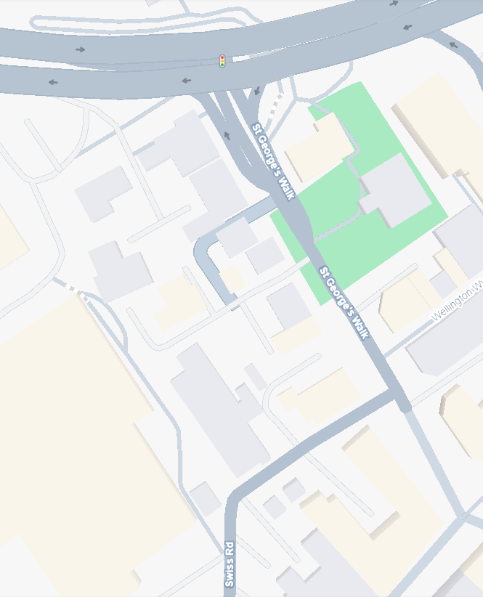

4.3 Site Access and Security
4.3.1 The works will be undertaken within an occupied area. It is recognized that the construction process is a live working environment and as such we understand the importance of segregating and securing the Project works to maintain a safe and controlled environment for employees and visitors.
4.3.2 Segregation plans will be provided and approved by the client it will then be then relayed back to the Client teams. In all instances alternative arrangements which will be in place, the duration in which these changes will remain along with a contact name and number should they have any queries.
4.3.3 The site will retain all the existing security arrangements and has a 24 hour (monitored) CCTV presence. This will remain throughout the development and will continue to be always left safe and secure, including outside working hours (if needed). Signage will be displayed indicating that there is no access for unauthorized persons. During the Christmas Period where the “building site” is closed, the Site will be covered by 24-hour manned security (in addition to the CCTV).
4.3.4 In addition, all people engaged in the project will undertake a project specific induction which will be delivered by the Site Manager.
4.3.5 The competency requirements of the Contractors will be verified during the prequalification stage and again on arrival to site. Full compliance with CSCS and affiliated schemes is mandatory for all parties.
4.3.6 Persons authorised to use plant and equipment are to ensure guards are in position and that any other safety devices, e.g., emergency stops are in working order.
4.3.7 All persons are to be trained, competent and authorised to operate plant and equipment ensuring the equipment is compliant with UK legislation i.e., full statutory inspections and maintenance records in place. Fire extinguishers are to be provided in the work areas as required by the hot works procedure.
4.3.8 Hording or hares fencing will be erected around site with double gates for access.
4.4 Lighting Arrangements
4.4.1 The Project will keep under review the requirement to introduce general movement lighting; however, this requirement is not foreseen due to the utilisation of existing pedestrian routes. Each Contractor provides their own task lighting, to ensure works are performed safely.
4.4.2 The use of halogen lamps is strictly prohibited.
4.5 Programme of Works
4.5.1 The construction period is estimated to be approximately 40 Weeks. Start on site in September 2026 and completion by end of June 2027.
4.5.2 The Swiss Road is to be utilized throughout the entirety of the development for construction traffic.
4.5.3 Demolition period scheduled for 4 weeks as first phase for this project.
4.5.4 Total construction program including demolition is 40 weeks.

4.6 Traffic Management
4.6.1 The site working hours will be 08:00hrs to 17:00hrs Monday to Friday and 08:00hrs to 13:00hrs Saturdays. These hours will apply to all operations including HGVs entering and leaving the site.
4.6.2 In exceptional circumstances, for safety and operational reasons, it may be necessary to work outside of these hours i.e., Sundays and Bank Holidays. Where this occurs, the hours and duration of work will be subject to consultation with the Local Planning Authority.
4.7 Traffic Management Principles
4.7.1 It is important that construction traffic and traffic on the existing highway network are managed to maximise construction efficiency and safety while minimising risk, inconvenience and nuisance to the public. This will be achieved through careful management, programming and co-ordination of all works and traffic accessing the site.
4.7.2 To minimise the impact of HGV movements on the existing highway network the following construction traffic management principles will be observed:
• The proposed main access routes to and from the site have been identified. All contractors and users of the site will be advised of these routes; and
• To minimise the impact that the construction works will have on residents and the surrounding environment, the Site Manager will be given several duties relating to the management of traffic. The Site Manager will be responsible for the following:
o Ensuring all delivery vehicles to and from the site are managed efficiently, reducing nuisance or unnecessary disruption to the operation of the existing highway network. The role will also include advising haulage contractors and their drivers of the most appropriate route to follow when approaching the site in particular providing advice on local width and weight restrictions;
o Ensuring traffic management principles and the mitigation measure are implemented and that the public highway is kept clear of mud and debris through ensuring that loads are suitably sheeted and secured and undertaking regular street cleaning, as necessary;
o A telephone contact number for the Site Manager will be displayed at the site entrance so that any issues relating to delivery vehicle movements can be quickly addressed; and
o Any breach of the principles contained within the document by haulage contractors or their drivers will be subject to a warning with any subsequent breach resulting in a ban from the site.
4.8 Documentation
4.8.1 All vehicles delivering materials will provide an appropriate delivery ticket which will include the following details:
• Driver’s name and vehicle registration.
• Quantity of material being delivered.
• Origin (site) of material.
4.9 Demolition Sequence
4.9.1 After asbestos is removed by licenced asbestos removal contractor demolition will commence.
4.9.2 First stage: demolition of garage on the rear of the site which will create access for large machinery and vehicles to site.
4.9.3 Second stage: demolition of main building from rear, gradually moving towards front of building using machinery and loading rubble into trucks to be taken away.
4.9.4 Scaffold will be erected on front of building, high street, to protect public for safe working practice. Scaffold will be removed as building reduced in height.
4.9.5 Dust will be kept to minimum using machinery and dumping demolition process by using water.
4.9.6 All services will be disconnected to allow safe environment for demolition to commence.
4.9.7 When main building is demolished scaffold will be erected around chimney with shoot to transport rubble in to skip below. Chimney will be removed manually. To minimise dust, skip will be dampened with water. Before scaffold is removed around chimney making good will commence on Clock house, using similar materials as excising to weatherproof Clock house wall. Scaffold removed after making good.
4.9.8 After all rubble removed from site, no rubble will be kept on site, it will be removed as building demolished, excising foundations and concrete floor will be removed and levelled.
4.10 Construction Sequence
4.10.1 After ground is levelled temporary electric and water supply will be connected to site.
4.10 2 Piling will commence on Block A, front of the site, by drilling, reinforcing and concreting to reduce vibration and noise. Piling for Block B will commence after Block A. Ground on Block B will be backfilled, levelled after piling and covered with hard standing sheeting to allow machinery and deliveries of materials driving over until Block A is built.
4.10.3 Ring beam on Block A will commence, followed by steel construction, blockwork and timber frame.
4.10.4 After Block A is built, materials for timber frame will be delivered and loaded on hard standing in the middle of site. Welfare will be moved to the Block A ground floor.
4.10.5 Hard standing will be removed from top of Block B piles and ring beam will commence followed by steel structure, blockwork and timber frame.
4.10.6 Majority of materials for building Block B will be stored in the middle of site prior building Block B. Smaller size materials will be loaded on to site using small size telescopic forklift due to restricted access under underpass.
4.11 Neighbour Management
4.11.1 Site manager will update neighbouring properties of works monthly and get feedback from neighbouring tenants weekly to minimise impact of construction activities and improve relationship.
4.11.2 Complaints, if raised, will be reported to site manager and documented on daily/weekly site report. As soon as complaint is raised, site manager will try to resolve it as soon as possible. In case if site manager can`t resolve it, complaint will be forwarded to project manager.
4.11.3 Contact details for site manager will be provided on safety signage on front and rear of site hording.

5.0 ENVIRONMENTAL MANAGEMENT AND MITIGATION MEASURES
5.1 General
5.1.1 The Contractor shall be sensitive to adjacent occupants’ staff concerns over dust, noise and vibration, particularly during busy periods. Where the Contractor receives a request to suspend their works from third parties out-with the contract due to dust, noise or vibration, the Contractor shall immediately upon receipt of the request report to the Employer’s Agent. Site specifics are detailed within the demolition RAMS Accompanying this document.
5.1.2 Works shall continue site until direct instruction from either the Employer’s Agent or Employer is received. The Contractor shall note that it may be necessary to reprogramme works such that noisy operations or activities which because significant vibration may need to be undertaken at pre-agreed times.
5.2 Dust
5.2.1 The Demolition Method Statement has identified the dust control measures in detail which are to deploy water cannons with mast assisted suppression This is detailed within the site-specific Method statement/Risk assessment. Vehicles accessing a site are often a primary source of airborne dust. Vehicles would therefore be subject to an on-site speed limit of 10mph and all vehicles delivering materials to the site would be sheeted.
5.2.2 Access roads will be suitably maintained and kept clear of debris. This will ensure that levels of dust associated with vehicles driving through the site are kept to a minimum. Haul roads and operational areas will be dampened down during dry weather. Areas of bare earth and material stockpiles would also be kept dampened down to minimise the potential for any windblown dust from surfaces.
5.2.3 Vehicle exhausts can cause surface dust to become airborne. It is therefore proposed that any vehicles or plant based at the site do not have their exhausts pointing in a downward direction.
5.2.4 Weather conditions can cause considerable problems with operations such as those proposed in terms of airborne dust and mud being tracked onto the public highway. It is therefore proposed to ensure that the Site Manager monitors weather conditions frequently and that action is taken to suspend operations, if necessary, until weather conditions allow. The Site Manager will monitor log the weather conditions within the Site Diary.
5.2.5 Any complaints relating to dust emissions will be recorded within the Site Diary. The Site Manager will be responsible for addressing any dust-related problems, including liaison with the complainant. The actions taken to address the issue will also be recorded to help avoid future recurrences.
5.2.6 In summary, it is proposed that dust is managed through a number of mitigation measures which would include, but not be limited to the following:
• Frequent monitoring of weather and site conditions by the Site Manager.
• Ensuring that all HGVs leaving the site transporting excavated engineering materials are sheeted to prevent dust.
• Enforcement of a 10mph speed limit on site to minimize dust arising from vehicle movements;
• Good housekeeping measures to promote a clean and tidy site particularly within the surfaced site reception area.
• Temporary closure of site during exceptionally windy conditions, if considered necessary by the Site Manager.
5.3 Mud and Debris
5.3.1 Measures will be in place to ensure that mud and debris is not tracked onto the public highway by HGV’s and other vehicles leaving the site.
5.3.2 A vehicle parking and site reception area would be located close to the main site entrance, and this will be kept clean through good housekeeping measures.
5.3.3 The Site Manager would monitor the condition of the vehicle parking and site reception area as well as the public highway daily. If mud from the site is observed on the highway the Site Manager would arrange for a road sweeper to rectify the problem. The source of the mud and/or debris would also be investigated, and the incident reported in the Site Diary, including any remedial measures taken, so that the likelihood of a repeat incident is significantly reduced.
5.3.4 If any further complaints are received regarding mud or debris on the public highway, the Site Manager will investigate the source of the problem and arrange for any remedial action required as a matter of urgency.
5.4 Odour
5.4.1 There are no potential sources of odour at this site due to the inert nature of the engineering materials that will be utilised.
5.5 Noise
5.5.1 The construction works have the potential to give rise to noise. The following operational procedures will be implemented to reduce the potential for noise and to ensure that it does not result in an unacceptable effect on local amenity, including neighbours and other site users:
• All noise generating activity, including demolition, soil stripping, soil movement and stockpiling, placement of inert materials, restoration and seeding, will be confined to the operating hours permitted in the Planning Permission, except for emergency repairs of mobile plant and equipment.
• All plant and machinery will have effective silencers and be maintained in accordance with the manufacturer’s requirements.
• All equipment, when not in regular use, shall be switched off; and
5.5.2 Any complaints relating to noise will be recorded within the Site Diary. The Site Manager will be responsible for addressing any noise related problems, including liaison with the complainant. The actions taken to address the issue will also be recorded to avoid a recurrence and so that lessons can be learnt for the future.
5.6 Pests
5.6.1 The excavated materials will not attract pests such as birds, vermin or insects and therefore the management of pests is not considered necessary.
5.7 Litter
5.7.1 Due to the nature of the materials to be disposed on site, no litter will be generated and therefore the management of litter is not considered necessary.
5.8 Asbestos
5.8.1 This is covered within the demolition Method statement this has highlighted the need for the appointment of a registered removal contractor.

5.9 Vibration
5.9.1 The movement of plant and machinery will be monitored throughout the development
5.9.2 Vibration monitoring equipment will be deployed to ascertain individual movements and any plant or machinery assisted tasks.

