Aerial photograph of existing property. For reference
13 Windsor Road,
Waterlooville,
Hampshire.
PO7 6BA

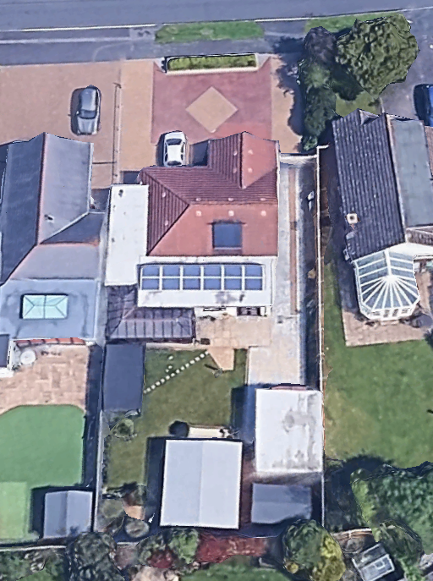
C.H Planning & Sales
112 Stubbington Lane,
Fareham,
Hants. PO14 2PE
Tel: 01329-661877
OS Licence: 100050691

