Sports Facilities Calculator
The Sports Facility Calculator (SFC) can help quantify the additional demand for key community sports facilities created by a new population.

The calculator is designed to estimate the demand for sports facilities created by a new community as part of a residential development. It also provides an estimated cost value for the new facilities that demand has created. It helps to answer questions such as:

- “How much additional demand for swimming will the population of a new development area generate?”
- “What would the cost be to meet this new demand at today’s values?”

The SFC is hosted on Sport England’s Active Places Power website: www.activeplacespower.com. For more details see the Tool Guide: https://www.support.activeplacespower.com/pages/sportsfacilitiescalculator

Criteria
The SFC results presented below are based on the following user entered criteria:

Area of Interest: Havant
Population demand estimated for: 4,086
Adjusted Demand: No
Swimming Pools: 0% | Artificial Grass Pitches: 0% | Indoor Bowls: 0%
Sports Halls: 0% | Outdoor Tennis Courts: 0%
Adjust Default Population Profile: No

Results
Date generated: 31/07/2026
Swimming Pools |  |  | Sports Halls
Demand adjusted by | 0% |  | Demand adjusted by | 0%
Square meters | 43.64 |  | Courts | 0.97
Lanes | 0.82 |  | Halls | 0.24
Pools | 0.21 |  | vpwpp | 286
vpwpp | 265 |  | Cost | £766,508
Cost | £989,760

Artificial Grass Pitches |  |  | Outdoor Tennis Courts
Demand adjusted by | 0% |  | Demand adjusted by | 0%
Pitches | 0.11 |  | Courts | 0.51
vpwpp | 81 |  | vpwpp | 80
Cost if 3G | £137,868 |  | Cost | £61,637
Cost if Sand | £124,656

Indoor Bowls Centres
Demand adjusted by | 0%
Rinks | 0.09
Centres | 0.01
vpwpp | 13
Cost | £40,654
Population Profile
Table
 | Current Calculation |  | Area of Interest Default |  | England
Age Group  (Years) | Male (%) | Female (%) | Male (%) | Female (%) | Male (%) | Female (%)
0 – 4 | 5.13 | 4.64 | 5.13 | 4.64 | 5.54 | 5.09
5 – 9 | 5.49 | 4.97 | 5.49 | 4.97 | 5.91 | 5.46
10 – 15 | 7.1 | 6.6 | 7.1 | 6.6 | 7.64 | 7.06
16 – 19 | 4.65 | 4.2 | 4.65 | 4.2 | 5.12 | 4.73
20 – 24 | 5 | 4.58 | 5 | 4.58 | 6.09 | 5.66
25 – 29 | 5.77 | 5.23 | 5.77 | 5.23 | 6.57 | 6.18
30 – 34 | 5.9 | 5.59 | 5.9 | 5.59 | 6.79 | 6.61
35 – 39 | 5.79 | 5.87 | 5.79 | 5.87 | 6.58 | 6.64
40 – 44 | 5.59 | 5.71 | 5.59 | 5.71 | 6.3 | 6.47
45 – 49 | 5.15 | 5.27 | 5.15 | 5.27 | 5.96 | 6
50 – 54 | 6 | 6.27 | 6 | 6.27 | 6.28 | 6.3
55 – 59 | 7.01 | 7.35 | 7.01 | 7.35 | 6.62 | 6.66
60 – 64 | 7.47 | 7.48 | 7.47 | 7.48 | 6.27 | 6.37
65 – 69 | 6.69 | 6.63 | 6.69 | 6.63 | 5.21 | 5.35
70 – 74 | 5.57 | 5.47 | 5.57 | 5.47 | 4.36 | 4.64
75 – 79 | 5.24 | 5.76 | 5.24 | 5.76 | 4.07 | 4.53
80 – 84 | 3.33 | 3.95 | 3.33 | 3.95 | 2.56 | 3.06
85 – 89 | 1.95 | 2.69 | 1.95 | 2.69 | 1.44 | 1.96
90+ | 1.17 | 1.74 | 1.17 | 1.74 | 0.69 | 1.23

Population Profile Comparison

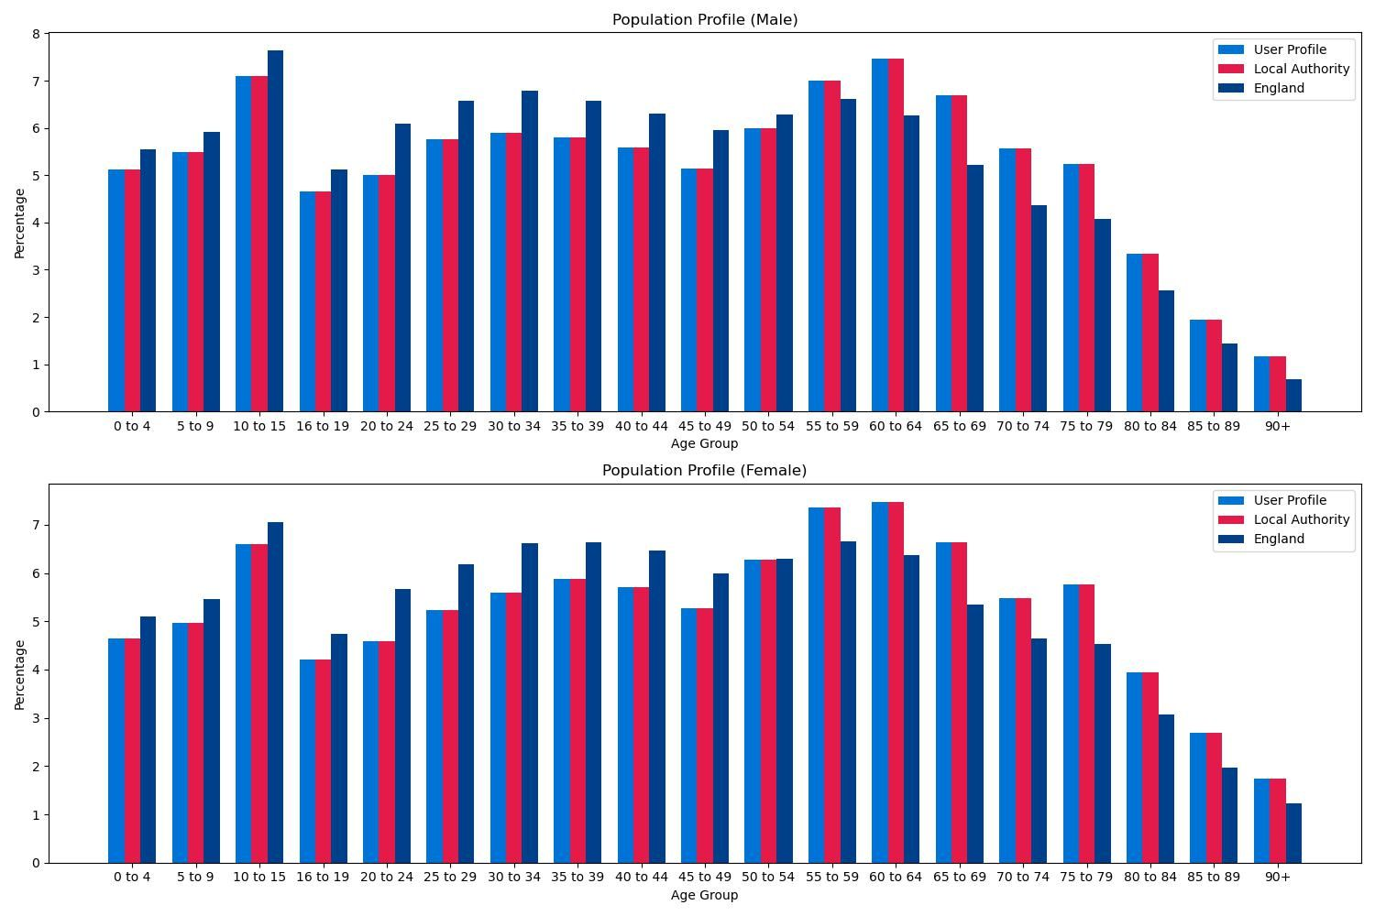
Population and Cost Data Sources
The SFC uses the following default data sources which are updated annually:

Population data
Office of National Statistics
2025 population projections, based on the 2021 Census data and modified by the 2018-based subnational population projections for Local Authorities. Adapted from data from the Office for National Statistics licensed under the Open Government Licence v3.0. For further information visit: ONS Population Projections webpage.

Greater London Authority
2025 London Borough projections are modified by Greater London Authority (GLA) 2022-based Demographic Projections – ward populations, identified capacity scenario, © GLA, 2022. For further information visit: Greater London Authority Housing-led Population Projections webpage.

Cost Data
Capital Costs
Sport England’s 3rd Quarter 2025 facility cost updates. For further information, visit: Sport England Facility Costs Guidance.

Cost Variations
Building Cost Information Service (BCIS) (all-in Tender Price Index) pricing adjustment factors (2025). For further information, visit Building Cost Information Service website.

Definitions
The definitions and units expressed in the report outputs are:
Swimming Pools
Square meters: Water space area (square metres)
Lanes: Swimming pool (main/general) lane equivalents (25m x 2.125m)
Pools: 4-lane (25m x 8.5m) Swimming Pool equivalents
vpwpp: Visits per week in the peak period
Cost: Estimated cost to build specified 5-lane Swimming Pool equivalents (25m x 10.5m). A 5-lane pool size is chosen to ensure a representative cost, that is, a 4-lane pool cost is not underestimated (by applying a 6-lane cost) and/or a 6-lane pool overestimated (by applying a 4-lane cost).

Sports Halls
Courts: Badminton court equivalents (Main Sports Hall)
Halls: 4-court Main Sports Hall (34.5m x 20m) equivalents
vpwpp: Visits per week in the peak period
Cost: Estimated cost to build specified 4-court Main Sport Hall (34.5m x 20m) equivalents.

Artificial Grass Pitches
Pitches: Full size AGP equivalent, where a pitch has minimum dimensions of 102m x 63m
vpwpp: Visits per week in the peak period
Cost if 3G: Estimated cost to build specified pitch equivalents. Costs are based on a senior football pitch size (106m x 70m), 60mm longer pile artificial grass carpet with fencing and artificial sports lighting.
Cost if Sand: Estimated cost to build specified pitch equivalents. Costs are based on pitch size of 106m x 70m, 23mm sand filled with fencing and artificial sports lighting.

Outdoor Tennis Courts
Courts: Outdoor tennis court equivalents.
vpwpp: Visits per week in the peak period
Cost: Estimated cost to build specified court equivalents. Costs are based on a four court (26.58 x 64.01m) macadam and fenced facility with artificial sports lighting.

Indoor Bowls
Rinks: Indoor bowl rink
Centres: 6-rink Indoor Bowls Centre equivalents
vpwpp: Visits per week in the peak period
Cost: Estimated cost to build specified 6-rink Indoor Bowls Centre equivalents

