

Whitsbury Road Women’s Refuge

Whitsbury Road, Havant PO9 5SP
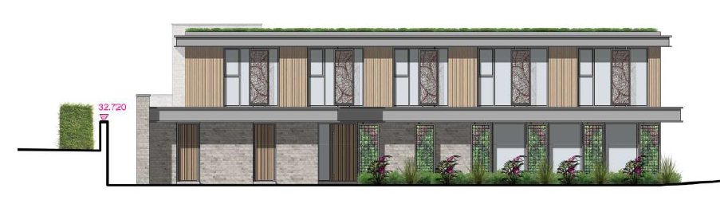

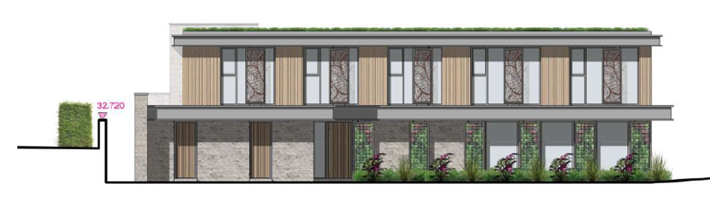
Construction Environmental Management Plan

Contents
1.0 Introduction 3
2.0 The Aim of this Document 3
3.0 Construction Start/Completion Dates 4
4.0 Proposed hours in which vehicles will arrive and depart 4
5.0 Access arrangements for Vehicles 4
6.0 Proposed routes for Vehicles attending site 4
7.0 Size of Vehicles 5
8.0 Access drawing for manoeuvres into the site 5
9.0 Control of dirt and dust on the public highway 5
10.0 Storage and Security 6
11.0 Managing Impacts of Construction Activity 6
11.1 Noise and Pollution Control Measures 6
11.2 Dirt and Dust during Construction 7
11.3 Ecology 7
11.4 Targeting zero non-hazardous waste to landfill 7
12.0 Energy usage 8
13.0 Fuel consumption 8
14.0 Waste Management 8
15.0 Further information 9
16.0 Appendices 9

1.0 Introduction

This construction environment management plan (CEMP) has been prepared to support the planning application APP/24/00096.

The purpose of this document is to outline how the Main Contractor and sub-contractors will manage and where practical minimise the impact of the development’s construction upon the sites surroundings. Vale Southern Construction is committed to achieving high environmental standards and working closely with the local community and other parties throughout the development period.

2.0 The Aim of this Document

This document covers the methodology principles for the handling and monitoring for all elements of the project that will could have any environmental impact during the build of the new care facility. This document will outline our proposed methodology for the environmental logistics and waste operations that will take place on site ensuring the safe working conditions for the contractors on site and the neighbouring areas both residential and commercial.

The purpose of the CEMP is to manage and mitigate potential impacts of the construction process on the following sensitive receptors surrounding the site:

- Air, noise and vibration impacts on residential properties along Whitsbury Road and surrounding areas.

- Minimising dust and sediment impact on surrounding properties.

- Containing debris and mud within the site boundary for the benefit of surrounding highways.

3.0 Construction Start/Completion Dates

Main Contract Works
- Commence: November 2025
- Completion: September 2026

4.0 Proposed hours in which vehicles will arrive and depart

In general the hours in which vehicles will arrive and depart will coincide with site hours which are 8.00am to 5.30pm in the evening, weekends 8.00am to 12.30pm, no Sunday working is permitted.
There will be occasions when heavy/wide loads will need to be delivered and removed from site outside of these hours.
Such deliveries would have a site manager present to supervise.

5.0 Access arrangements for Vehicles

The roads around site will be covered by a 30 MPH speed limit, however, it may be prudent to restrict the speed of visiting contractor and supply chain vehicles to a much lower speed. All vehicles arranged for any reason by the Principal Contractors must adhere to a safe speed limit.

Owing to the residential environment around the works, we have developed a traffic management plan. This would be accompanied by a marked-up drawing, to clearly show vehicle entry and delivery route, pedestrian means of access and egress to the site, routes and methods for removal of waste from the internal site areas, pedestrian segregations around site. Signage will be required to prevent unauthorised access for vehicles and any gates are to remain closed during construction works with suitable contact numbers for those with legitimate reason to access. Access needs to be maintained at all times for emergency vehicles.
All construction vehicles needing to reverse around the site should be always guided by a trained vehicle Marshal.

Parking will be on adjacent public roads, but we will endeavour to limit vehicle parking in Whitsbury Road.
There will be no parking on site, so all operatives and visitors will be encouraged to park in Prospect Lane.

6.0 Proposed routes for Vehicles attending site

Details of agreed access/egress routes will be issued to all our suppliers and subcontractors. This will be policed as far as practical, but it must be recognised that we have no jurisdiction over the vehicles once they have left our site.

Preferred route into Whitsbury Road would be off B2149 and onto Forestside Avenue or Prospect Lane into Whitsbury Road.

Refer to our appendices for further information

7.0 Size of Vehicles

Numerous types of delivery vehicles will be used to bring materials to and from the site. These include:

    - Skip lorries. These will include roll on/roll off skips (approx. size 7.5m long and 2.4m wide) and standard 8-yard skips for waste (approx. size 7m long and 2.4m wide.

    - Ready mix concrete lorries. (approx. size 8.25m long and 2.45m wide).

    - Flat bed delivery vehicles for the delivery of various materials including scaffolding, steelwork, reinforcement, bricks/blocks, timber, roofing materials, plaster, joinery etc. (approx. size 8.5m long and 2.45m wide.

    - We will try to avoid any deliveries that require articulated lorries.

    - Mobile cranes

8.0 Access drawing for manoeuvres into the site

Please refer to our appendices

9.0 Control of dirt and dust on the public highway

Mud and debris on the road are one of the main environmental nuisance and safety problems arising from construction sites. Vale Southern will make provision to minimise this problem by leaving as much of the existing concrete slab in place until the last moment before removal.

Wheel Cleaning Methodology

In the early stages of the project when ground works are being carried out, wheel washers will be used to wash down all vehicles that enter/leave the construction site when conditions are wet and the possibility to transfer mud.

Maintaining Public Roads/Paths

We will also make provision for cleaning of the road if required by an approved road sweeper.
We will insist on all muck away vehicles to be fully sheeted to minimise the risk of any mud over-spilling onto the highway.

Where possible the intention is to tarmac any loading / traffic area’s, this preventing the transfer of ground spoils out onto road surfaces and causing excessive airborne dust. We will also consider water suppression should dust become excessive.

    - Structures and building during demolition.
    - Unpaved areas that are subject to traffic or wind.
    - Sand, spoil and aggregate stockpiles.
    - During loading/unloading of dust generating materials.

10.0 Storage and Security

Areas for the Storage of Plant and Materials used during Construction

Secure, hard-standing space has been designated near and around loading and unloading areas for the initial storage of plant and materials.

The site entrance is hoarded and gated, all remaining boundary’s to the project are 2m high walls and therefore would not receive hoarding.
This is being monitored and maintained on a regular basis to ensure a safe working environment and prevent risk to the general public.

Additional fencing will be erected and taken down around hazardous or restricted areas of the site as required.

11.0 Managing Impacts of Construction Activity

We will continue to maintain a close relationship with the appointed Environmental Health officer and will inform them of any exceptional circumstances in which construction activity may surpass agreed levels or restrictions, well in advance.

11.1 Noise and Pollution Control Measures

Noise levels will be controlled, active, relevant legislation including the Control of Pollution Act 1974 and the Environmental Protection Act 1990, to the Environmental Health Officer’s satisfaction. Best practice will be adopted by the contractor, in particular by adhering to the BSI Code of Practice for Noise and Vibration Control on Construction and Open Sites. Points of reference include:
To mitigate Noise pollution, we shall:

- Carry out low impact demolition methods, non-percussive plant to be used where practicable
- The project main structure is a pre-fabricated timber frame
- Plant to be fitted with Silencers when practicable
- The plant appointed to site is in good condition and is compliant with EC directive 2000/14/EC & UKSI2001/1701
- Plant is to be stored away from neighbouring properties when practicable
- Plant shall not be used unless necessary
- Site hoarding is erected at the entrance to prevent
- The project will be serviced via mains electric, this mitigates the use of generators
- The project will be Registered and evaluated as part of the Considerate Contractors Scheme
- All operatives to receive a full project induction where responsibilities and duties will be conveyed.

11.2 Dirt and Dust during Construction

VSC will adhere best practice guidance when mitigating dust / dirt and apply the following throughout the construction phase. These practices are direct guidance from the IAQM document Assessment of Dust from demolition and Construction (2024)

- Contact details will be displayed at all times to register concerns
- VSC shall record and publish any registered complaint
- The site is under full time supervision and subsequently this issue will be monitored daily
- A weekly assessment shall be carried out in coordination with the IAQM ‘Dust and Air Emissions mitigation Measures’ Guidance. This document is available in the CEMP folder held onsite
- During construction all waste will be contained in covered skip and when haling spoil the wagon will not depart site unless covered
- Where practicable hard surfaces will be laid for traffic / pedestrian area’s
- Wheels to be washed should the conditions require this practice to avoid soil transfer
- The project entrance is constructed of a 2m high, fully boarded hoarding. This is to reduce dirt, dust and debris being blown directly out of the site entrance. This is a ply sheet and wooden post construction.
- Record all dust and air quality complaints, identify cause(s), take appropriate measures to reduce emissions in a timely manner, and record the measures taken.
- Make the complaints log available to the local authority when asked.
- Record any exceptional incidents that cause dust and/or air emissions, either on- or off-site, and the action taken to resolve the situation in the log book.
- Increase the frequency of site inspections by the person accountable for air quality and dust issues on site when activities with a high potential to produce dust are being carried out and during prolonged dry or windy conditions.
- Plan site layout so that machinery and dust causing activities are located away from receptors, as far as is possible.
- Erect solid screens or barriers around dusty activities or the site boundary that are at least as high as any stockpiles on site.
- Avoid the use of diesel or petrol powered generators and use mains electricity or battery powered equipment where practicable.
- Only use cutting, grinding or sawing equipment fitted or in conjunction with suitable dust suppression techniques such as water sprays or local extraction, e.g. suitable local exhaust ventilation systems.
- Ensure an adequate water supply on the site for effective dust/particulate matter suppression/ mitigation, using non-potable water where possible and appropriate.
- Minimise drop heights from conveyors, loading shovels, hoppers and other loading or handling equipment and use fine water sprays on such equipment wherever appropriate.
- Avoid bonfires and burning of waste materials.
- Ensure effective water suppression is used during demolition operations.

11.3 Ecology

Construction activity will be controlled in a way which mitigates damage or destruction to the ecology of the area, and enabling the implementation of the ecological enhancement scheme of the completion of the construction works.

11.4 Targeting zero non-hazardous waste to landfill

As part of our environmental approach, we seek to source materials from local companies, provided that specification requirements and costs are met.

Initiatives to reduce waste streams will include as far as practically possible:

    - Minimising raw material waste through analysing design and construction techniques where possible

    - Making a commitment to develop waste minimisation opportunities by maintaining a role in the management of the supply chain during construction.
    - Liaison with suppliers through the off-site consolidation centre to enable packaging material to be sent back for reuse, the use of off‐ cuts where possible and the recycling of off-cut material by the supplier

    - Engaging subcontractors in the process of maximising the use of recycled aggregates hard-core and alternative cements according to application;

    - Optimising reverse logistics in liaison with the Logistics Partner for vehicles delivering from the off- site consolidation centre.

Vale Southern will require it’s contractors to always maintain a duty of care to ensure that waste generated during the construction period is handled in accordance with the relevant legislation governing its storage, transfer, treatment and disposal.

12.0 Energy usage

Where practicable, we seek to source green energy providers for the construction phase. Meters will be supplied for the site enabling energy consumption levels to be monitored.

13.0 Fuel consumption

We strive to procure local contractors for the project therefore minimising transport costs and impact on the local environment.

14.0 Waste Management

Our approach to the treatment of waste is to employ a specialist waste management contractor as a trade package. This contractor is responsible for:

    - Ensuring the site is kept clean and safe.
    - The collection of waste from a central point.
    - Segregation of waste on site.

As the principal contractor we will ensure that all access routes, fire escapes and staircases are swept and kept clear of debris on a regular basis to maintain high standards of health and safety on the project. All general areas of the project will be swept clean on a weekly basis. There will be a constant labour team throughout the project managed by Vale Southern to ensure all these areas are made a priority.
Sub-contractors will be responsible for removing waste emanating from their works to a central point on site.

15.0 Further information

Once works have started on site, site reports, regular surveys, site waste management plan (SWMP), weekly safety inspection report and noise records will be produced.

16.0 Appendices

