

PLANNING AND OPERATIONAL STATEMENT

For: Replacement stable barn and rationalisation of existing equestrian buildings.

At: Poundcroft Livery Stables, adjacent to 173 Havant Road, Hayling Island
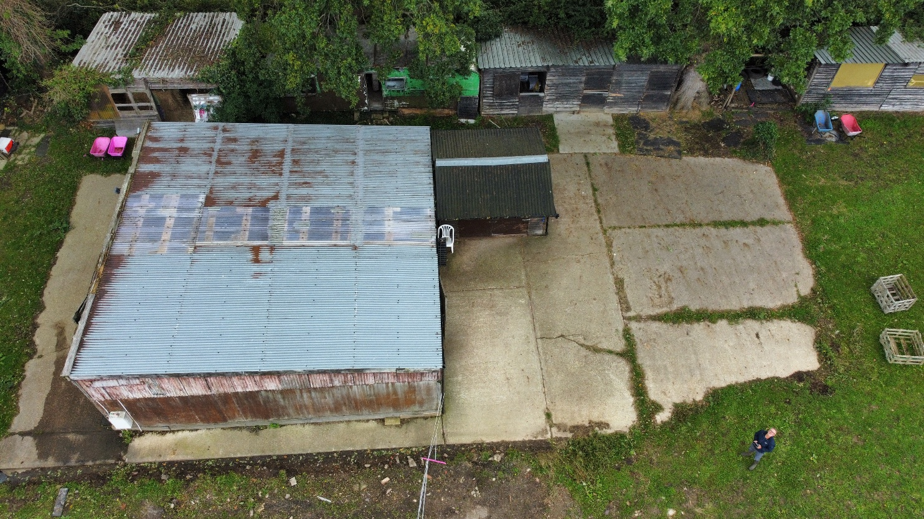
Prepared by:
Equestrian Blueprint
enquiries@equestrianblueprint.co.uk
https://equestrianblueprint.co.uk/
August 2026

Contents
1. Introduction 3
2. Site and planning history 3
3. The proposal 3
4. Planning policy context 4
5. Planning assessment 4
6. Planning balance and conclusion 6

1. Introduction
This Planning Statement supports an application for a replacement stable barn at Poundcroft Stables. It explains the planning history, the principle of development and the principal considerations relevant to the proposal. It should be read with the submitted drawings, Design and Access Statement and the separate statements dealing with operations, transport, trees, ecology, biodiversity net gain, drainage, flood risk and nutrient neutrality.
The application does not seek a new equestrian use or an intensification of activity. It replaces and rationalises buildings serving a long-established livery yard, using the existing developed and hard-surfaced part of the site.

2. Site and planning history
The site lies west of Havant Road and north of 173 Havant Road, between the road and the Hayling Billy Trail. The stable yard and associated buildings are concentrated at the southern end of the land, where mature boundary vegetation provides a backdrop and established hardstanding serves the existing equestrian use. Grazing land extends northwards and is divided by an east-west drainage ditch.
The equestrian use is established. A Certificate of Lawfulness was granted on 13 July 2000 under reference 99/57253/000 for recreational horse uses and the stabling and exercising of horses. The site has also been known and operated as a livery stable for several decades. The present application concerns the buildings supporting that established use, rather than a material change in the use of the land.
Planning permission APP/17/00052 was granted in March 2017 for re-profiling of land and associated hardstanding. The Council's later delegated report for application APP/19/00744 records that those works were undertaken and that the earlier enforcement notice relating to imported materials was withdrawn.
Application APP/19/00744 concerned a materially different proposal: a 28-pitch, fully serviced campsite, new internal roads and hardstandings, shower and toilet blocks, an office, year-round occupation and associated visitor activity. It was refused because of the scale and effects of that development. Those findings do not establish an objection to the existing equestrian use or to proportionate replacement facilities serving it. Indeed, the report expressly described the site as used for horse grazing with associated stables and buildings, largely screened against the wooded southern boundary.

3. The proposal
The proposal is for one replacement stable barn containing six stables and ancillary feed and bedding storage. It will stand on the established concreted yard area. A new concrete pad will be formed over the existing hardstanding to provide a sound and level base, without extending the principal hardstanding footprint into the paddocks.
Smaller peripheral buildings will be removed and not replaced. The result will be a simpler and more coherent arrangement, reduced built clutter and more space around retained trees. Historically the yard accommodated approximately 13 horses in 11 stables. Under the proposed arrangement there will normally be three to five horses and no more than six, served by six stables. There will be no staff, riding school, lessons, competitions, clinics or organised events.

4. Planning policy context
Planning applications must be determined in accordance with the development plan unless material considerations indicate otherwise. The adopted development plan for Havant includes the Havant Borough Local Plan (Core Strategy), adopted in 2011, and the Local Plan (Allocations), adopted in 2014. The emerging Building a Better Future Plan is a material consideration only to the extent appropriate to its stage and the consistency of its policies with national policy.
The policies most relevant to this modest replacement scheme include Core Strategy policies CS11 (the special environment and heritage), CS15 (flood and coastal erosion), CS16 (high-quality design), CS20 (transport and access) and the detailed policies DM8 (natural features), DM9 (coastal zone), DM10 (pollution), DM12 (travel impacts) and DM14 (parking). Allocations Plan policies AL1, AL2 and DM23 are also relevant. These policies seek, in summary, development that responds to its context, protects landscape and ecological interests, manages flood and drainage effects, safeguards amenity and provides safe access and parking.
The National Planning Policy Framework is an important material consideration. Its decision-making principles support sustainable development, good design, efficient use of land, protection of the natural environment, safe access and avoidance of increased flood risk. The weight applied to individual development-plan policies is a matter for the decision-maker, having regard to their consistency with the Framework and the circumstances of this application.

5. Planning assessment
5.1 Principle of development
The principle is supported by the established equestrian use and the presence of existing stables, stores and hardstanding. A functional stable building is necessary infrastructure for the safe keeping and welfare of horses already lawfully kept and stabled at the site. Locating the replacement within the existing yard is the least intrusive means of providing that accommodation.
The proposal does not spread development into the open grazing land or create a new destination use. It reduces the historic number of stables and horses and consolidates scattered accommodation into one building. In principle, the replacement and rationalisation of existing equestrian buildings is appropriate to the site and its established use.
5.2 Character, design and landscape
The barn has a straightforward form, modest scale and recessive materials characteristic of equestrian and rural buildings. It will be read in the context of the existing stable yard, hardstanding and mature boundary vegetation, rather than as an isolated incursion into the paddocks. Its detailed design and materials are addressed in the Design and Access Statement and drawings.
The concerns raised in 2019 related to widespread campsite hardstanding, dispersed structures, caravans, tents, vehicles and associated paraphernalia across the southern field. None of those features forms part of this application. By removing peripheral buildings, keeping development on the established yard and reducing the overall operational scale, the current proposal will simplify rather than urbanise the site.
5.3 Residential amenity and operations
The use will remain small-scale and private/recreational. Normal activity will occur approximately between 07:00 and 20:00. One regular person will usually visit twice daily, with an occasional Sunday rider, infrequent deliveries and professional visits. Lighting will be limited to downward-directed bulkhead fittings used only when needed for safe circulation and switched off when the yard is unoccupied. There will be no amplified sound or organised events.
This is a substantial contrast with the potential occupation of a 28-pitch campsite by more than 100 people considered in 2019. The proposed barn will support a reduced established operation and will not introduce a materially harmful source of noise, disturbance or overlooking.
5.4 Access, parking and transport
The existing access from Havant Road will remain unchanged. The site has parking for approximately six cars and one horse trailer will be retained. Routine activity equates to two arrivals and two departures per day. Feed and bedding deliveries are approximately monthly, the farrier attends every six to eight weeks, veterinary attendance is normally annual apart from emergencies, and horses are transported less than once per month.
The application therefore does not intensify use of the access; it supports materially fewer horses than the historic livery operation. The highway concerns associated with the proposed campsite and its visitor turnover are not comparable. Further detail is provided in the Transport Statement and Operational Statement.
5.5 Trees and natural environment
No tree or boundary vegetation removal is required. The barn is confined to the developed yard and the removal of peripheral structures will improve the space around retained trees. Appropriate protection during construction is set out in the Tree Statement.
The proposal will not bring public recreation or unrestricted visitor activity closer to the harbour. It reduces the intensity of an established equestrian operation, with grazing continuing north of the ditch and riding taking place off site. Ecology, designated-site considerations, biodiversity net gain and nutrient neutrality are addressed in the accompanying statements. Taken together, these demonstrate a proportionate, managed proposal with effects fundamentally different from those of the refused campsite.
5.6 Flood risk, drainage and environmental management
The replacement barn is a non-residential equestrian building serving an established use; it does not provide sleeping accommodation or create the vulnerability associated with year-round caravans and camping. The established site drainage arrangement will remain. The reuse of the existing hardstanding avoids additional land take and limits disturbance.
A managed pine-pellet bedding system will be used, there will be no stable washdown or foul runoff, and manure will be held in a sealed and bunded clamp before removal as required by Northney Farm contractors. The Drainage Statement, Flood Risk Assessment Addendum and Nutrient Neutrality Mitigation Statement explain these matters in detail and demonstrate that the rationalised scheme will not increase flood risk or nutrient discharge.

6. Planning balance and conclusion
The application provides a practical replacement building for a long-established and lawfully recognised equestrian use. Its principal benefits are the reduction from eleven to six stables, the reduced number of horses, consolidation of scattered buildings, reuse of existing hardstanding, improved tree relationships and better-controlled bedding and manure management.
There is no new access, no expansion into open grazing land, no arena, no public or organised activity and no intensification of traffic. The design is appropriate to the established yard and the accompanying proportionate statements address the site-specific environmental constraints. The proposal is therefore consistent with the overall objectives of the development plan and the National Planning Policy Framework. Planning permission should be granted, subject to any necessary proportionate conditions.

