

TREE AND ECOLOGY STATEMENT

For: Replacement stable barn and rationalisation of existing equestrian buildings.

At: Poundcroft Livery Stables, adjacent to 173 Havant Road, Hayling Island
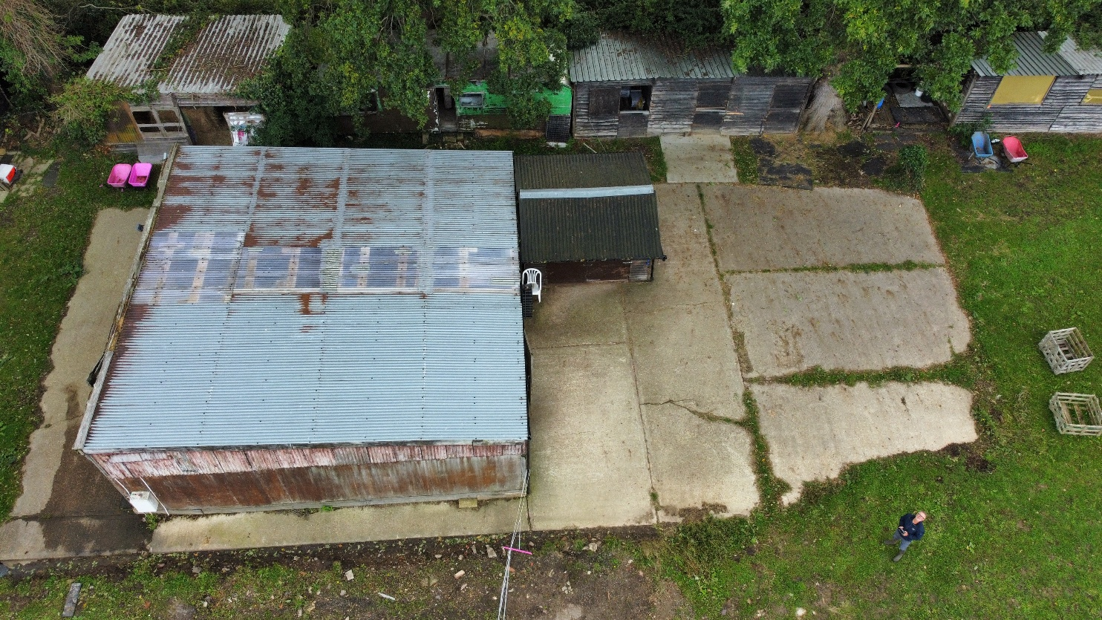
Prepared by:
Equestrian Blueprint
enquiries@equestrianblueprint.co.uk
https://equestrianblueprint.co.uk/
August 2026

Contents
1. Purpose and scope 3
2. Site context and established baseline 3
3. Re-profiling and the ecological baseline 3
4. Trees 4
5. Ecology 5
6. Species precautions and lighting 5
7. Assessment and conclusion 6

1. Purpose and scope
This combined statement considers the likely effects of the replacement stable barn on trees and ecology. It should be read with the application drawings, Design and Access Statement, Planning Statement and the separate documents dealing with operations, biodiversity net gain, drainage, flood risk and nutrient neutrality.
The statement is proportionate to a proposal confined to the established stable yard and existing hardstanding. It is not a Preliminary Ecological Appraisal or an arboricultural survey. Its purpose is to identify the relevant site constraints, explain the planning history and set out practical avoidance measures for a modest replacement scheme.

2. Site context and established baseline
The site has been known and operated as a livery stable for several decades. A Certificate of Lawfulness was granted on 13 July 2000 under reference 99/57253/000 for recreational horse uses and the stabling and exercising of horses. Existing stable buildings, stores, hardstanding and managed yard areas are therefore established features of the southern part of the site.
The wider land includes grazing north of the east-west drainage ditch and mature trees along the southern and south-western boundaries. The delegated report for APP/19/00744 records that the ditch and a western strip of the site are locally designated as a Site of Importance for Nature Conservation, and that the wider land lies close to the internationally designated habitats of Langstone Harbour. The report also identifies the field within the Solent Waders and Brent Goose Strategy as a Secondary Support Area. Those wider constraints are acknowledged and are not treated as having been removed by the previous engineering works.

3. Re-profiling and the ecological baseline
The planning history is important when identifying the appropriate baseline for the part of the site affected by this application. The Council's delegated report for APP/19/00744 records that imported soils, aggregate and hard core were placed on the southern section of the site during 2015 and 2016. Although enforcement action initially required their removal, planning permission APP/17/00052 was subsequently granted in March 2017 for re-profiling of the imported topsoil and associated hardstanding.

The same report confirms that the authorised works were undertaken, the drainage ditch was cleared and the earlier enforcement notice was withdrawn. The re-profiled levels and associated hardstanding consequently form part of the established planning and physical condition of the southern yard; they are not unauthorised works that the current application relies upon or seeks to regularise.
This history does not extinguish the ecological designations affecting the wider land, nor does it establish a legal precedent that ecological considerations no longer apply. It does, however, mean that any description of the habitat condition before the authorised re-profiling is not, by itself, an appropriate current baseline for the already developed yard. The present proposal should be assessed against the land as it now lawfully exists: an established equestrian yard comprising buildings and hardstanding, adjoining but distinct from the grazing land, ditch and boundary vegetation.
This conclusion is consistent with the County Ecologist's observations recorded in the 2019 report. The site was described as improved grassland and as not likely to be of significant ecological value in its own right, although the saline ditch was noted to support notable plants and the wider field retained importance as a Secondary Support Area. The current application does not involve the ditch, the northern grazing land or the conversion of the wider field to a new intensive use.

4. Trees
Mature boundary trees provide screening, landscape structure and potential wildlife habitat. The 2019 delegated report identified significant trees, including oaks, along the southern and south-western boundaries and referred to draft Tree Preservation Order 13539. The current status and precise extent of any order should be confirmed by the Local Planning Authority, but the proposal has been designed on the basis that all trees and boundary vegetation will be retained and protected.
The replacement barn will occupy the established yard and hardstanding. No tree, hedgerow or other boundary vegetation is proposed for removal. Smaller peripheral structures will be removed and not replaced, reducing built clutter close to retained trees and improving their long-term setting. Unlike the 2019 campsite scheme, the proposal does not require shower blocks, buried service networks or extensive new hard surfacing dispersed through the site.
The following precautions will apply during demolition and construction:
Temporary protective fencing will be positioned to separate retained trees and soft ground from the construction area before work starts and retained until construction is complete. The fence will be installed after the peripheral structures have been removed. See drawing PB2.
No plant, materials, spoil, fuel, cement washings or fires will be permitted beneath tree canopies or within fenced tree-protection areas.
Construction traffic and working activity will remain on the existing access, yard and hardstanding wherever practicable.
No excavation, level reduction or new underground service trench will be undertaken within retained soft ground around trees. If an unforeseen need arises, work will stop and appropriate arboricultural advice will be obtained before proceeding.
Demolition close to trees will proceed inward, towards the existing hardstanding, so that debris and machinery do not encroach beneath retained canopies.

5. Ecology
The proposal is a replacement and rationalisation of buildings serving an established equestrian use. It does not create a new public destination, extend built development into the grazing land, introduce a riding arena or increase activity beside the harbour. Historically the yard accommodated approximately 13 horses in 11 stables. The proposed six-stable arrangement will normally accommodate three to five horses and never more than six.
The ecological concerns raised in 2019 were directed principally to a materially different 28-pitch campsite. At capacity that scheme could have introduced more than 100 people, year-round occupation, extensive hardstanding, lighting and unrestricted recreational activity close to the harbour. The current proposal introduces none of those effects. Riding takes place mainly off site, grazing will continue north of the ditch, and there will be no competitions, lessons, clinics or organised events.
The construction footprint is already occupied by equestrian buildings or hardstanding and is of very limited intrinsic habitat value. No ditch, pond, grazing field, tree, hedgerow or other semi-natural habitat will be lost. The drainage ditch and its buffer will remain undisturbed. Managed bedding, the bunded manure clamp and the established drainage arrangements are addressed separately and are intended to prevent contaminated runoff reaching the ditch or harbour.

6. Species precautions and lighting
The following reasonable precautions will ensure that the modest works do not inadvertently harm wildlife:
Before demolition, the buildings will be checked for active bird nests and readily visible evidence of bats. If evidence of bats or features with credible bat-roost potential are identified, work to that part of the building will pause and advice will be obtained from a suitably qualified ecologist.
Vegetation clearance is not proposed. If any minor clearance becomes unavoidable, it will take place outside the main bird nesting season where practicable. If undertaken during the nesting season, the affected vegetation will first be checked and any active nest left undisturbed until it is no longer in use.
Any excavations left open overnight will be covered or provided with a means of escape for small animals.
Materials and waste will be contained within the yard and removed promptly; no waste or liquid will be deposited in the ditch or on adjoining grazing land.
External lighting will be limited to low-output, downward-directed bulkhead fittings required for safe circulation. It will be used only when necessary during the stated operating hours and switched off when the yard is unoccupied, avoiding illumination of trees, the ditch and the wider field.

7. Assessment and conclusion
The proposal is confined to the established developed portion of a decades-old equestrian site. The authorised 2017 re-profiling and associated hardstanding, followed by withdrawal of the enforcement notice, are material to the present-day baseline. They demonstrate that the current yard condition is established, although they do not remove the separate ecological importance of the ditch, grazing land or nearby designated sites.
Against that baseline, the replacement barn causes no material habitat loss. All trees and boundary vegetation will be retained; the ditch and grazing land will remain undisturbed; peripheral structures will be removed; and activity will reduce materially from the historic livery operation. With the stated tree-protection, species and lighting precautions, the proposal is unlikely to result in significant adverse effects on trees, protected species or the ecological function of the wider site.
If, during the Council's consideration or during the pre-demolition inspection, previously unknown evidence identifies a credible protected-species constraint, that specific matter can be addressed before the relevant work proceeds. On the information presently available, the scale, location and reduced intensity of the proposal support a proportionate conclusion without the extensive ecological investigations sought for the fundamentally different campsite scheme.

