

NUTRIENT NEUTRALITY STATEMENT

For: Replacement stable barn and rationalisation of existing equestrian buildings.

At: Poundcroft Livery Stables, adjacent to 173 Havant Road, Hayling Island
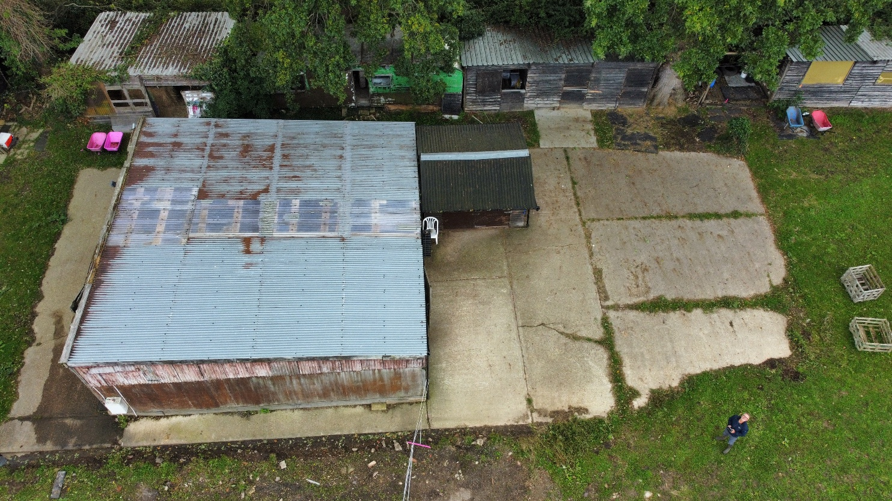
Prepared by:
Equestrian Blueprint
enquiries@equestrianblueprint.co.uk
https://equestrianblueprint.co.uk/
August 2026

Contents
1. Introduction 3
2. Existing and Proposed Use 3
3. Drainage and Water Quality 3
4. Manure Management 4
5. Betterment 4
6. Conclusion 5

1. Introduction

This statement has been prepared in support of the planning application for the replacement stable building at the site.

The site is already in established equestrian use and the proposal does not introduce a new equestrian activity. Rather, it provides a substantially reduced and better managed operation, with improved measures for the containment and removal of manure, urine and soiled bedding.

The purpose of this statement is therefore to demonstrate that the proposal will not introduce a new nutrient-bearing drainage pathway and, importantly, will provide significant betterment when compared with the existing equestrian use.

2. Existing and Proposed Use

Historically, up to 13 horses have been accommodated on the site, with 11 existing stables.

The proposed replacement building will provide only six stables, together with ancillary storage for feed, bedding and other equipment. The number of horses kept on the site will be limited to a maximum of four.

This represents a reduction of approximately 69% in the maximum number of horses compared with the historic operation of the site.

This substantial reduction in the intensity of the equestrian use will, in itself, significantly reduce the potential quantity of manure, urine and soiled bedding generated on the site.

3. Drainage and Water Quality

The existing surface water drainage arrangement serving the stable area will be retained.

Surface water will continue to enter the same existing gully, travel through the same existing pipework and discharge from the same existing outfall into the same ditch.

The proposal therefore creates no new drainage route or additional discharge point to the ditch.

The principal objective of the proposed management arrangements is to minimise the possibility of nutrient-bearing material entering this existing surface water system.

The stables will use Silva Crumb pine pellet horse bedding, a highly absorbent equine bedding product. This will assist in absorbing and retaining urine and moisture within the bedding, allowing it to be removed as part of the normal mucking-out process rather than becoming free liquid capable of entering the yard drainage system.

No manure, soiled bedding or contaminated stable washdown water will be intentionally discharged into the surface water drainage system.

4. Manure Management

Manure and soiled bedding will be regularly removed from the stables and placed within a bunded manure clamp.

The bunded construction will provide containment and prevent manure and associated material from migrating into the surrounding drainage system.

The accumulated manure and used bedding will be removed from the site by the contractor at Northney Farm.

This provides a controlled management route for the principal potential source of equestrian-derived nutrients, rather than allowing manure or soiled bedding to remain dispersed around the stable yard or enter the surface water drainage system.

5. Betterment

The proposal should be assessed against the established equestrian use of the site.

The existing drainage route to the ditch will remain unchanged; however, the potential nutrient loading associated with the equestrian operation will be substantially reduced and more effectively controlled.

The betterment comprises:

reduction from up to 13 horses to a maximum of six;
reduction from 11 stables to six;
use of highly absorbent pine pellet bedding to contain urine and moisture at source;
regular removal of manure and soiled bedding;
storage within a bunded manure clamp;
controlled off-site removal by the contractor at Northney Farm; and
no new drainage route or discharge point to the existing ditch.

6. Conclusion

The proposal represents a substantial reduction in the intensity of the established equestrian use while introducing improved measures for the containment and management of potential nutrient sources.

The existing surface water drainage arrangement will remain unchanged, with no new discharge point or pathway to the receiving ditch.

At the same time, the reduction from 13 horses to a maximum of four, combined with absorbent bedding, a bunded manure clamp and controlled off-site removal of manure and soiled bedding, will materially reduce the potential for equestrian-derived nutrients to enter the surface water drainage system.

The proposal therefore represents a clear betterment over the existing situation in terms of nutrient management and protection of water quality, with the principal potential sources of nutrient-bearing material being contained at source and removed from the site.

