

DESIGN AND ACCESS STATEMENT

For: Replacement stable barn and rationalisation of existing equestrian buildings.

At: Poundcroft Livery Stables, adjacent to 173 Havant Road, Hayling Island
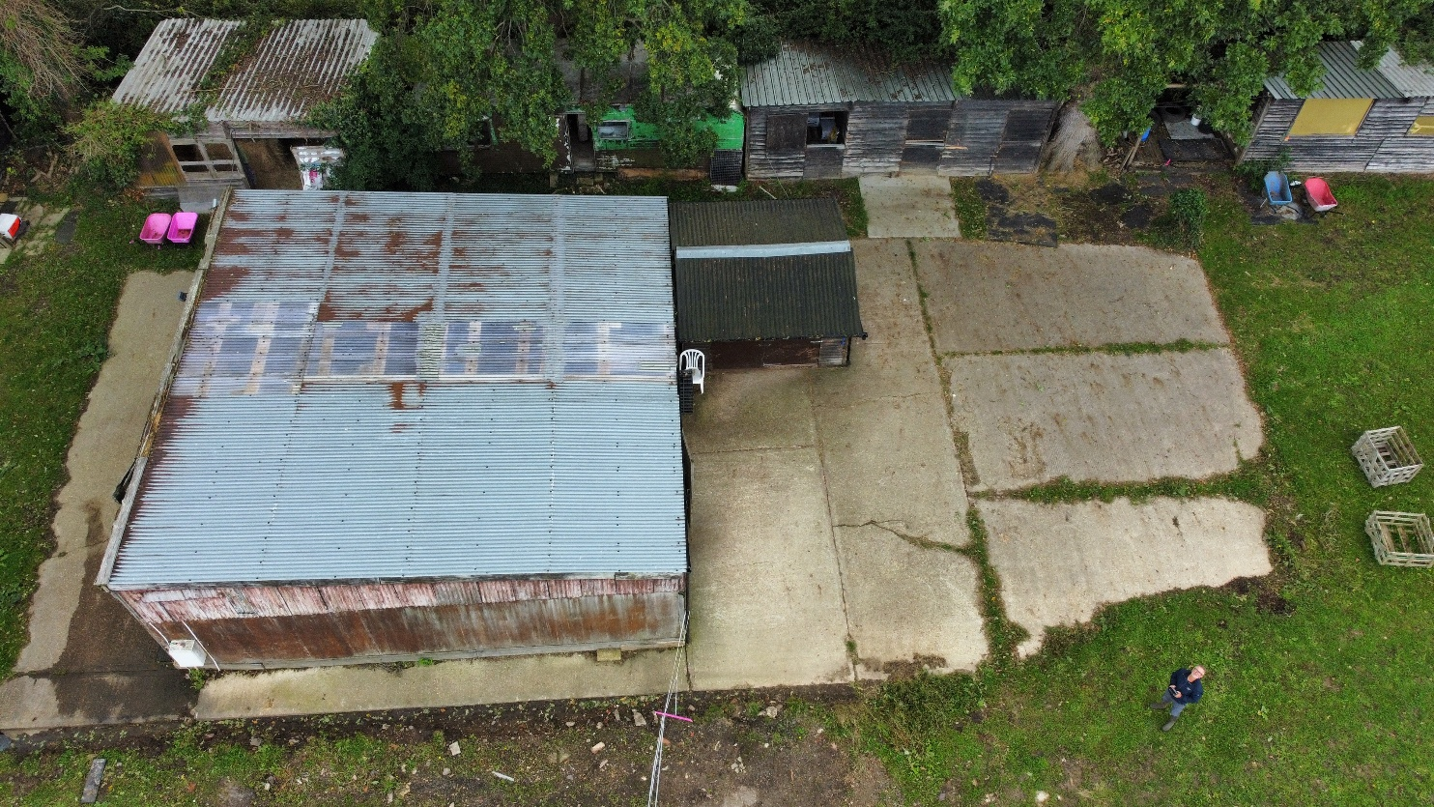
Prepared by:
Equestrian Blueprint
enquiries@equestrianblueprint.co.uk
https://equestrianblueprint.co.uk/
August 2026

Contents
1. Introduction 3
2. Site and established use 3
3. The proposal 3
4. Design 4
5. Access 4
6. Sustainability and environmental approach 5
7. Conclusion 5
8. Photomontage 6

1. Introduction
This Design and Access Statement accompanies an application for a replacement stable barn at Poundcroft Stables. It explains the site context, the established equestrian use, the design approach and the access arrangements. Detailed matters relating to planning policy, operations, transport, trees, ecology, biodiversity net gain, drainage, flood risk and nutrient neutrality are addressed in the accompanying statements.
The proposal is deliberately limited in scope. It does not introduce a new equestrian use or seek to intensify activity. It replaces and rationalises buildings serving a livery yard that has been known and operated as such for several decades.

2. Site and established use
The site lies to the west of Havant Road and immediately north of 173 Havant Road, between the road and the Hayling Billy Trail. It extends northwards across equestrian grazing land and is divided by an east-west drainage ditch. The stable yard and associated buildings occupy the southern part of the site, where established hardstanding and mature boundary vegetation provide a settled context for the equestrian structures.
The equestrian use is long established. A Certificate of Lawfulness was granted in July 2000 (reference 99/57253/000) for recreational horse uses and the stabling and exercising of horses. The site has also been known locally as a livery stable for decades. The current application therefore concerns the replacement and improvement of facilities supporting an existing use.
Historically, the yard accommodated approximately 13 horses in 11 stables. The revised arrangement will provide six stables, with normally three to five horses on the site and a maximum of six. This represents a clear reduction in the scale and intensity of the established operation.

3. The proposal
The application proposes a single replacement stable barn containing six stables together with the ancillary feed and bedding storage needed for the yard. The building will be positioned on the established concreted yard area. No extension of the existing principal hardstanding footprint is required; instead, a new concrete pad will be formed over the existing hardstanding to provide a sound, level base and modestly raise the finished building level.
A number of smaller peripheral structures will be removed and will not be replaced. Consolidating the accommodation into one coherent barn will reduce built clutter, improve the organisation of the yard and open up space around retained trees.

4. Design
4.1 Amount and layout
The amount of development has been kept to the minimum reasonably required for the reduced equestrian operation. Six stable bays are provided within a straightforward, functional layout, with facilitites for storage of tack, feed and tools and an area for grooming horses, contained within the barn rather than dispersed among separate outbuildings. The siting makes efficient use of the existing yard and avoids encroachment into the grazing land.
4.2 Scale and form
The barn adopts the simple rectangular form and modest scale traditionally associated with equestrian and agricultural buildings. Its proportions, roof form and height are shown on the submitted drawings. The building remains visually contained within the established stable-yard area and relates directly to the existing hardstanding and boundary screening.
4.3 Appearance and materials
The external treatment is intentionally recessive and appropriate to the rural and equestrian setting. Timber boarding and a simple dark-toned roof will give the barn a familiar stable-building appearance, while the limited palette avoids unnecessary visual complexity. Exact finishes and colours are identified on the submitted elevations.
4.4 Landscape and trees
The proposal is concentrated on the existing developed and hard-surfaced part of the yard. It does not require the removal of boundary vegetation or expansion into the open paddocks. The removal of peripheral structures will reduce clutter and improve the relationship between the built form and the mature trees along the southern boundaries. Tree protection and construction precautions are set out separately in the Tree Statement.
4.5 Lighting and amenity
External lighting will be limited to modest bulkhead fittings required for safe circulation during the yard's normal operating hours. The fittings will be downward directed, used only when reasonably necessary and switched off when the yard is unoccupied. There will be no floodlighting, amplified sound, public-address equipment, lessons, competitions, clinics or organised events.

5. Access
5.1 Vehicular access and parking
The established vehicular access from Havant Road will remain unchanged. The application does not require any new access, alteration to the highway boundary or additional access infrastructure. The existing on-site parking area can accommodate approximately six cars, ensuring that vehicles can park clear of Havant Road.
The replacement barn will serve a materially smaller operation than the historic livery yard. Routine attendance is limited, deliveries are infrequent and horse transport normally occurs less than once per month. The access arrangements and traffic effects are explained further in the Transport Statement and Operational Statement.
5.2 Pedestrian and inclusive access
The stable barn is a private equestrian building rather than a public facility. Access within the yard will nevertheless remain direct and practical, using the established hard-surfaced area. The level and consolidated arrangement will provide safer everyday movement for people, horses and yard equipment than the present collection of buildings.

6. Sustainability and environmental approach
The design follows a reuse-first approach. Retaining the existing hardstanding as the underlying base avoids unnecessary excavation, new land take and the environmental cost of removing and replacing a serviceable developed surface. The consolidation of the stables and storage within one building also reduces the number of structures across the yard.
Clean roof water and yard drainage will continue to use the established drainage arrangements, as detailed in the Drainage Statement and Flood Risk Assessment Addendum. There will be water harvesting measures installed. Improved bedding and manure management will reduce the risk of contaminated runoff, while the substantially reduced number of horses provides an environmental betterment over the historic operation.

7. Conclusion
The proposal provides a proportionate replacement barn for a long-established livery stable. It reduces the number of stables and the normal horse population, reuses the existing hardstanding, removes smaller peripheral buildings and brings the remaining accommodation into a single well-organised structure. The existing access is retained and no arena or new public activity is proposed.
The result will be a simpler, less intensive and better-managed equestrian yard, with a functional design that respects the established character of the site and its surroundings.

Cont

8. Photomontage
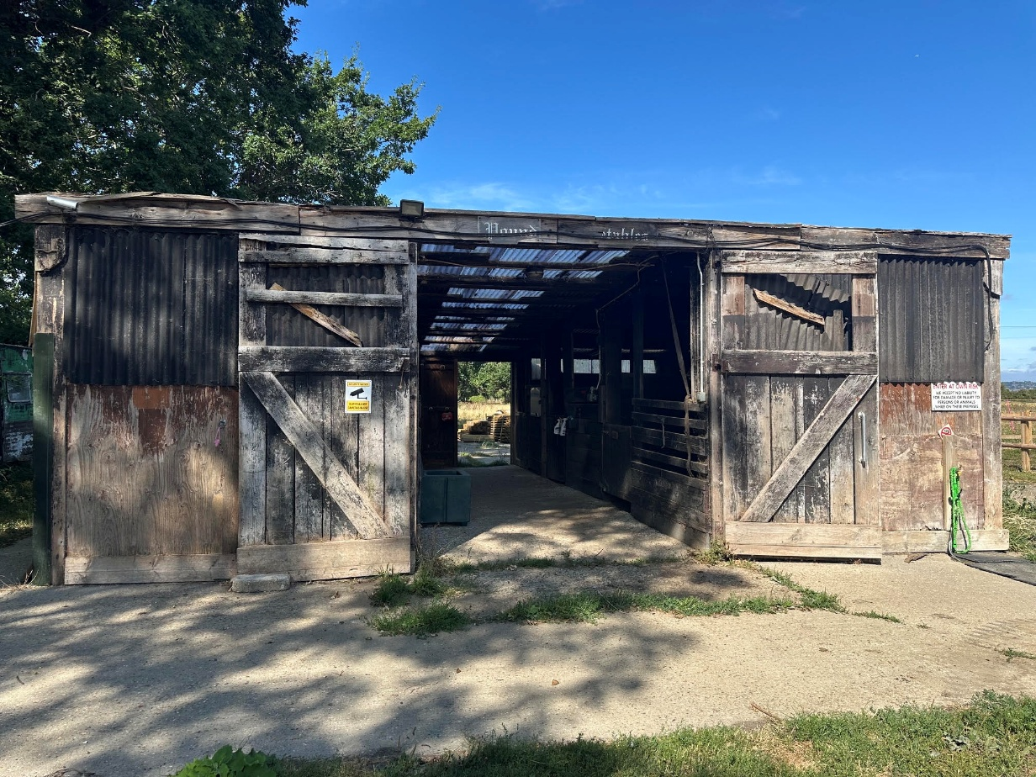
Figure 1 Existing dilapidated barn
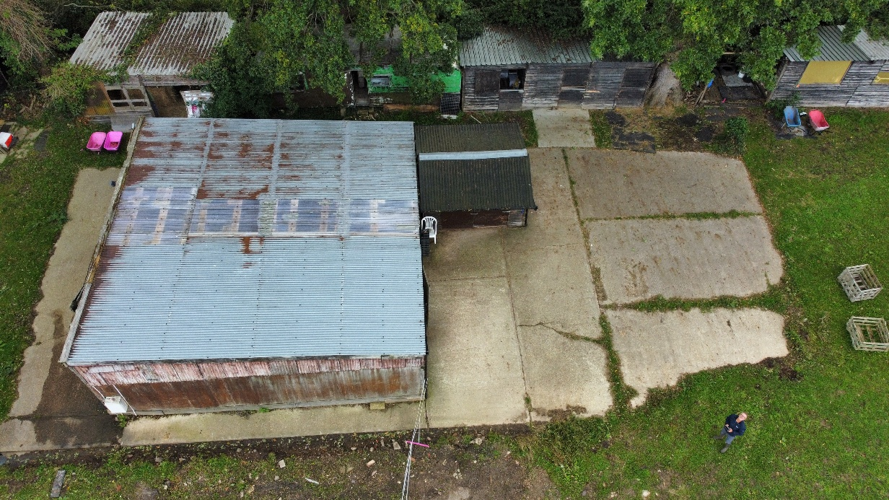
Figure 2 Existing barn, peripheral buildings and caravan.

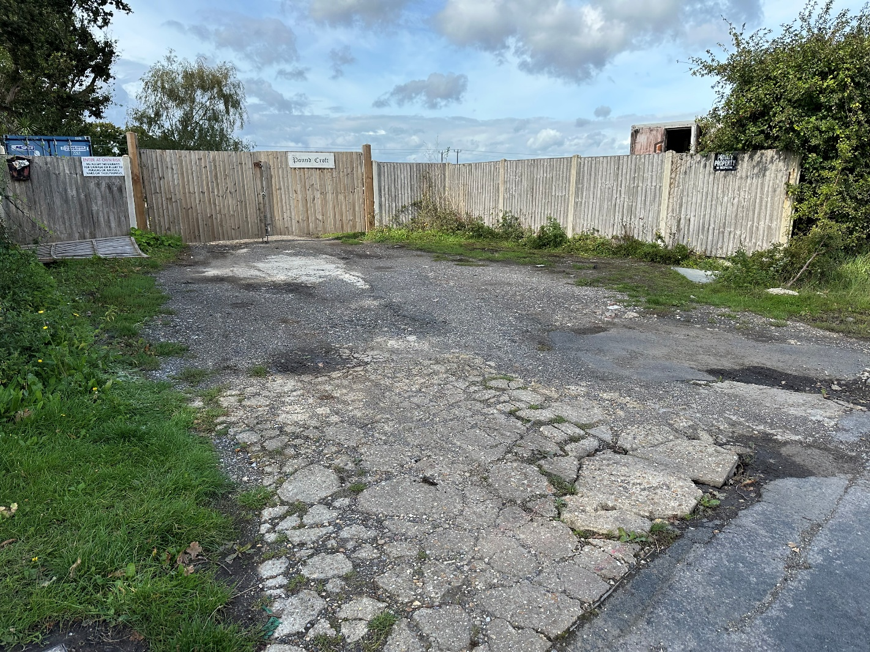
Figure 3 Existing access allowing a pull-off from the highway.
Buildings to be removed
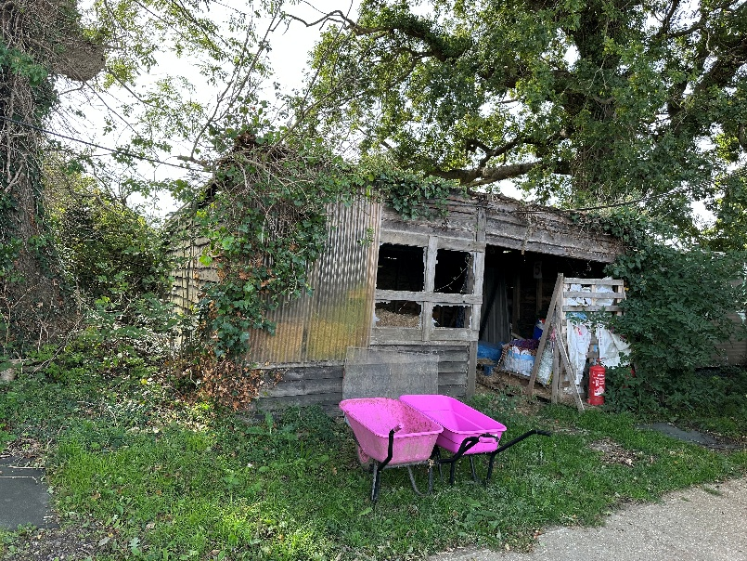
Figure 4 Haystore
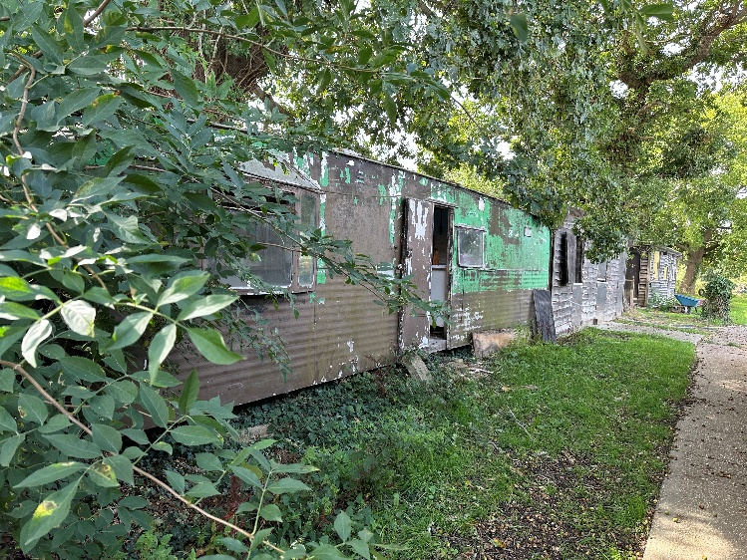
Figure 5 Caravan
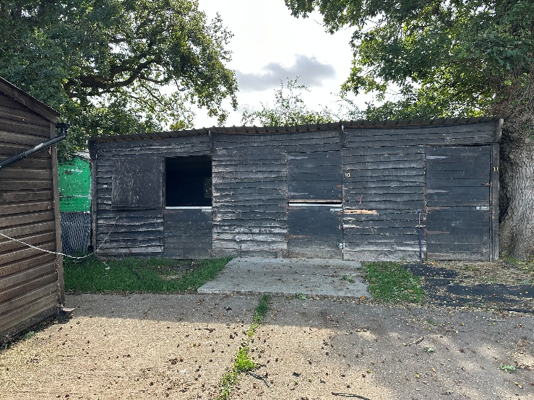
Figure 6 Stables
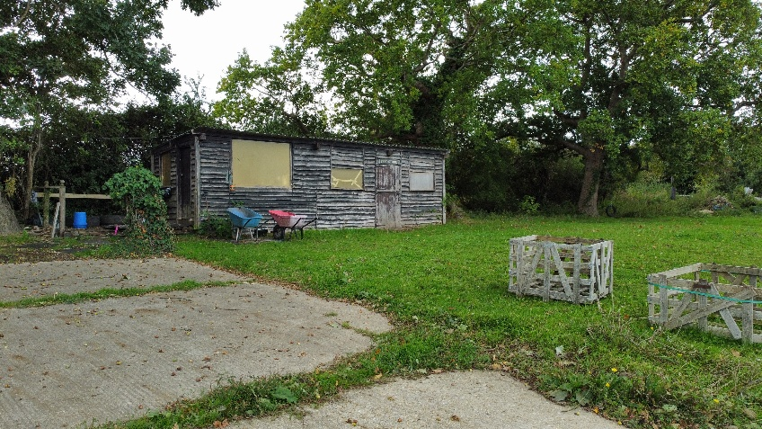
Figure 7 Tackrooms and feedstore

