

FRA ADDENDUM

For: Replacement stable barn and rationalisation of existing equestrian buildings.

At: Poundcroft Livery Stables, adjacent to 173 Havant Road, Hayling Island
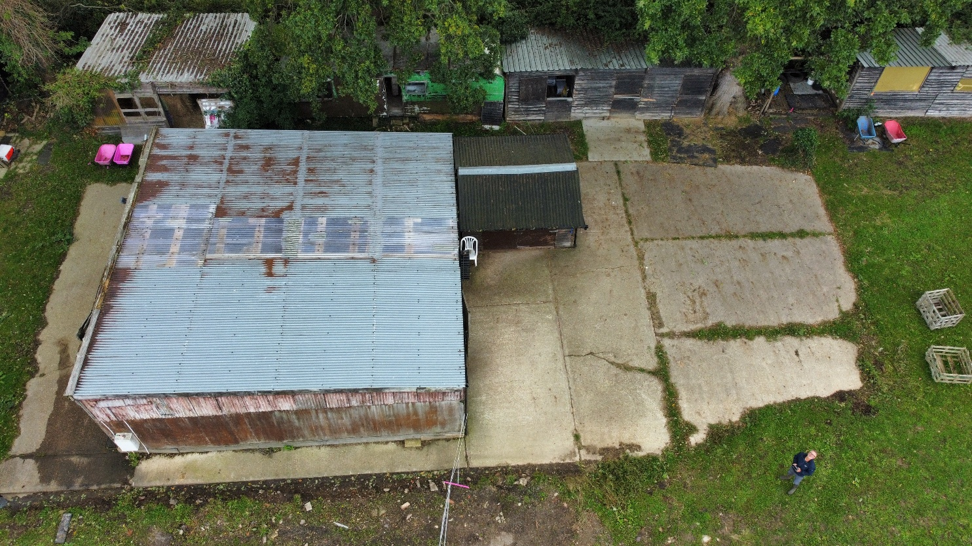
Prepared by:
Equestrian Blueprint
enquiries@equestrianblueprint.co.uk
https://equestrianblueprint.co.uk/
August 2026

Contents
1. Purpose of Addendum 3
2. Revised Development 3
3. Effect on the Original Flood Risk Assessment 4
4. Floodplain and Ground Levels 4
5. Surface-Water Drainage 5
6. Flood-Resilient Construction and Management 5
7. Sequential Approach 6
8. Conclusion 6

1. Purpose of Addendum

This addendum should be read alongside the Flood Risk Assessment prepared by Unda Consulting Limited, reference 97033-Loxton-HavantRd v1.0, dated February 2026.

The original Flood Risk Assessment considered:

Demolition of the existing stables and barn, construction of a new stable building and construction of a 20m x 40m riding arena.

The application has subsequently been revised. The proposed riding arena has been removed from the scheme in its entirety. The revised application now relates only to:

Demolition of the existing stable building and associated peripheral structures and erection of a replacement stable building on the existing stable yard and hardstanding.

This addendum considers the implications of that change for the conclusions of the original Flood Risk Assessment.

2. Revised Development

The replacement stable building would principally occupy the area of the existing stable building and established concrete hardstanding. The existing concrete base is to be retained and reused, with a new concrete pad formed over it to provide a suitable base for the replacement building.

No riding arena, additional arena surfacing or associated groundworks are now proposed.

Several existing peripheral buildings and structures around the stable yard would also be removed and would not be replaced. The development is therefore concentrated on the established stable yard rather than extending built development or hard surfacing across the adjoining field.

The established private equestrian use of the site would continue. There would be no change to a more flood-sensitive form of development and no residential accommodation is proposed.

3. Effect on the Original Flood Risk Assessment

The removal of the riding arena represents a material reduction in the physical extent of the development assessed in the original Flood Risk Assessment.

In particular, the revised proposal would:

avoid the formation of approximately 800 square metres of arena surfacing;
avoid the excavation, levelling and construction works previously associated with the arena;
avoid the introduction of additional surfacing across the adjoining field;
concentrate the development on an existing stable yard and established hardstanding;
retain and reuse the existing concrete base;
remove a number of peripheral structures which would not be replaced; and
result in a smaller and less extensive development than that originally assessed.

The principal sources and characteristics of flood risk identified within the original Flood Risk Assessment remain unchanged. The site remains within Flood Zone 3 and the previously identified risks from tidal flooding, surface water and groundwater continue to apply.

However, the revised proposal does not introduce any additional or more vulnerable use. Stable buildings and land used for equestrian purposes fall within the “less vulnerable” flood-risk classification. The classification of the site would therefore remain unchanged following development.

4. Floodplain and Ground Levels

The replacement stable building would be erected within the established stable-yard area and principally over an existing impermeable concrete base. The proposal does not involve a general raising of levels across the field or the creation of a raised riding arena.

The new concrete pad over the existing slab would result in a limited and localised increase in the level of the replacement building. This is necessary to provide a suitable, durable and flood-resilient base while avoiding the more disruptive removal of the existing concrete.

Given its limited footprint, its position over existing hardstanding and the tidal nature of the identified flood risk, this localised construction would not be expected to materially affect tidal flood levels, floodplain conveyance or flood risk to surrounding property.

The original FRA concluded that there would be no unacceptable loss of flood storage. That conclusion is strengthened by the removal of the riding arena and the concentration of the revised development on the existing developed part of the site.

5. Surface-Water Drainage

The existing stable building and yard already benefit from an established drainage arrangement. The replacement building would continue to use the existing drainage infrastructure, with the roof and yard drainage remaining materially as existing.

There would be no riding arena requiring a separate drainage system and no additional arena runoff to manage. The reuse of the existing stable base also limits the creation of new impermeable surfacing.

Consequently, the revised proposal is not expected to result in a material increase in the rate or volume of surface-water runoff from the site. Indeed, the removal of peripheral structures without replacement may result in a modest reduction in the overall developed footprint.

The detailed drainage arrangement should nevertheless be checked during construction and retained in good working order. Gutters, downpipes, gullies and drainage connections should be kept clear and maintained for the lifetime of the development.

6. Flood-Resilient Construction and Management

The flood-resilience and management measures recommended in the original Flood Risk Assessment remain applicable to the replacement stable building where relevant to its form and use.

These should include:

a robust concrete floor incorporating an appropriate damp-proof or waterproof membrane;
the use of durable and water-resistant materials at lower levels;
electrical fittings, controls and other vulnerable services positioned above floor level so far as practicable;
secure drainage covers and non-return protection where appropriate;
registration with the Environment Agency’s flood-warning service;
removal of horses, vehicles and portable equipment from the site when a flood warning is issued and it is safe to do so; and
maintenance of an appropriate flood-warning and evacuation procedure.

References in the original FRA to refuge on the first floor of a property are not applicable to the proposed single-storey stable building. The appropriate response to a forecast tidal event would be early evacuation of people and animals before access conditions deteriorate.

7. Sequential Approach

The proposal concerns the replacement of established stable accommodation within an existing equestrian site. The building has a clear operational need to be located alongside the existing grazing land, yard and associated equestrian infrastructure.

The proposal would not establish a new residential, commercial or visitor use. It would replace existing equestrian buildings on their established site and would remain within the “less vulnerable” flood-risk classification.

The revised scheme is also more sequentially preferable within the site than the original proposal because it avoids extending development into the adjoining field and concentrates construction on the previously developed stable-yard area.

8. Conclusion

The removal of the proposed riding arena significantly reduces the extent of development considered by the February 2026 Flood Risk Assessment.

The revised proposal:

remains a “less vulnerable” use;
replaces existing stable accommodation within the established yard;
principally reuses existing hardstanding;
avoids approximately 800 square metres of arena construction;
avoids general ground raising across the field;
removes peripheral structures which would not be replaced;
does not materially increase impermeable surfacing or surface-water runoff; and
would not be expected to increase flood risk elsewhere.

Subject to the continued application of the relevant flood-resilient construction, drainage maintenance, flood-warning and evacuation measures identified in the original Flood Risk Assessment, its overall conclusion remains applicable.

The revised stable-only development is therefore considered acceptable in flood-risk terms and represents a less extensive and potentially less consequential form of development than the scheme originally assessed.

