PLANNING, DESIGN AND ACCESS STATEMENT

PROPOSED NEW BUILDING FOR SPUR ELECTRON LTD
HAYWARD BUSINESS CENTRE
NEW ROAD, HAVANT PO9 2NL
ɫ
- The Applicant
  - Spur Electron is an SME (small and medium-size enterprises) space company founded in Havant in 1982. For more than forty years the company has been involved in most Europe’s major space programmes including manned space activity, such as Spacelab and Space Station Columbus and deep space missions including the enormously successful Rosetta probe. Its client base currently spans some fifteen European companies as well as India, China, Korea, Japan and South Africa.
  - The company is a key supplier of EEE component Engineering and Procurement services to the space and defence industry, taking ideas and designs and turning them into reality. The company has expert teams in component engineering, procurement, laboratory analysis, assembly, research and development and has an outstanding name in the space industry for being able to assist in the procurement and testing of electronic components.
  - Spur Electron is unique in the UK, with only two or three companies in Europe offering a similar service. Further, it is the only European Space Agency approved space assembly company of printed circuit boards and module build in the UK.
  - The company provides internal training for employees to gain accreditation for the ESA certificate and finances staff to attend IPC Training Courses. It has recently agreed with Airbus to become a centre for apprenticeships.

- Hayward House – The Existing Site
  - Hayward House was built in the 1990’s and is a two-storey building of brick construction with a traditional style pitched roof standing in a site of 0.86 ha. It has a total floor area of 639 sqm. The layout of the building and the site are shown on Drawing No. 2423-6C. The principal uses in the building are manufacturing, engineering, laboratory testing and research and development as well as stores and inspection. The offices are ancillary to the other uses.

  - Within the building the approximate areas occupied by each use are:
- Manufacturing and engineering - 216.50 sqm.
- Research and Development - 137.00 sqm.
- Stores and Inspection - 85.50 sqm.
- Offices - 117.00 sqm.
This amounts to a total of 556.00 sqm. The remaining floorspace is occupied by welfare facilities, a canteen and circulation space.
  - Access is from New Road in the south-eastern corner of the site, and there is a large car-parking area to the south and east of the building. The car-park surface is mainly red block paving with tarmac for the individual car-parking spaces. The main door is approached up a gentle ramp with a brick wall on either side. There is some landscaping in the form of a hedge along the front of the building, either side of the entrance ramp, which continues along part of the western boundary. There is also a similar hedge along the boundary with Senator Press, the adjoining property to the east, and a further hedge and planting at the northern edge of the car park, between Hayward House and Senator Press, and adjoining the bin store. At present there are thirty-three car-parking spaces, plus 2 for the disabled. There is one EV charging point which is marked on the drawing.
  - There is provision for ten cycles on the northern boundary of the site and small bin store as shown on the drawing.

- The Proposed Development
New Office and Store Building
3.1 The proposal is to install a demountable modular two-storey structure at the eastern end of the existing building and to construct a link between the two as shown on Drawing No. 2423-7P. Modular buildings are structures constructed off-site in a factory setting, then transported and assembled on site. They are manufactured in sections, which are put together to form the complete building and are commonly used for hi-tech uses as they are adaptable and can be altered internally to meet changing requirements.
3.2 The proposed building is manufactured by Phoenix Building Systems Limited, and the detailed layout and elevations are shown on Drawing No. 26-27748-01 Rev.E at Appendix A. The external dimensions of the building are 12m x 7.4m giving a gross external footprint of 88.8 sqm. The total additional floorspace created will be 186 sqm. The overall height above ground level will be 7.2m. Because the existing door in the flank wall of Hayward House is above ground level and accessed by a ramp, it will be necessary to construct a concrete base onto which the building will be fixed to ensure that the floor level inside Hayward House, the proposed link and the ground floor of the new building are the same. The finished floor level inside the new building will be approximately 268mm from the top of the foundation base.
3.3 The building itself is steel framed with Plastisol Steel cladding, and the windows and doors have metal frames. The proposed external colours have been chosen to harmonise with the existing building. The walls will be Albatross Blue, and the mid- band, fascia and plinth will be Wedgewood Blue, as will the window and door frames. These colours are shown on the chart at Appendix B.
3.4 Internally the building will provide 56.3 sqm of stores on the ground floor, together with two WCs. On the first floor there will be two offices each of 9.9 sqm and a larger office of 56.3 sqm. These are intended for occupation by staff involved in Research and Development and the manufacturing support team. Access to the building will be from the new link as shown on Drawing No. 2423-7P.

3.5 The new building will not only provide additional floor space but will also allow the accommodation within the existing building to be rationalised, including the creation of a larger manufacturing area on the ground floor. These changes will not be structural.

The Linking Building
3.6 The overall dimensions of the proposed link are 12m in depth x 3.4m I width. It is a single storey structure with an overall height of 7.2m above ground level. Entrance from the car park area will be through double doors designed to allow goods to be brought into the stores in the new building. There will be windows on either side, so the whole of this elevation is effectively glazed. On the northern elevation of the link will be a single door to allow access to the area at the rear, either side of which will be windows. There is an existing double door in the flank wall of Hayward House which will facilitate the movement of goods and machinery between the existing and proposed buildings. A further personnel door is proposed in the flank wall to give easy access for staff from the link to the main building. All the door and window frames will be Wedgewood Blue.
3.7 The existing double door in the flank wall of Hayward House is 370mm above ground level and accessed via a ramp. This means that, as referred to in paragraph 3.2, the floor level in the proposed new building and the link will also be raised above ground level, so a ramp from the car park will be constructed as shown on Drawing No 2423-7P to take account of the difference in level of the existing door and facilitate disabled access to both the new and existing buildings. The ramp will be paved in the same red block paving as the existing car park.

Car Parking
3.8 The business carried out by Spur Electron falls mainly within the class B1(b)(c) high tech/light industry, with ancillary offices. Current car parking standards in the Borough for this type of use as set out in the Parking SPD. Table 2 requires one space per 45 sqm. The car parking requirement is thus 19 spaces, based on 1 space per 45 sqm of floor area. The disabled parking requirement is 5% of the total which amounts to one space.
3.9 There are at present 33 spaces, plus two disabled, but they were laid out in the 1990’s and of the dimensions which were considered appropriate then. The opportunity is being taken in this scheme to increase the size of some of the spaces in keeping with the larger size of some cars. The existing parking provision is shown on Drawing No. 2423-6C. There are ten spaces along the front of Hayward House, each approximately 2.5m x 5m. This number will be reduced to eight and will include two disabled spaces either side of the entrance and close to the ramp for ease of access as shown on drawing 2423-7P Each has a vacant area adjoining to facilitate access to the vehicle in the space. The six normal spaces have been increased in size to 2.7m x 5m. Along the road frontage there will be eleven bays, each 2.4m x 5m. On the eastern boundary there are currently thirteen spaces, eight of which will be lost to the new development. Five spaces will remain along this boundary, each 2.4m x 5m. Thus, the total number of spaces provided will be 24, including two for the disabled. Although eight spaces will be lost the total provision of 23 plus two disabled exceeds the requirement of 19 plus one disabled space.
3.10 There are currently ten cycle racks on the northern edge of the site, but these will be affected by the proposed development. It is therefore proposed to construct a shelter at the front of the new building with three hoops to accommodate six cycles. The total number of staff proposed is 41 and the cycle parking requirement is 1 for every eight members of staff. Provision for six cycles as proposed is therefore adequate. One motorcycle space is proposed which meets the standard of one for every 25 car parking spaces.

Bin Store
3.11 A storage enclosure for two bins will be provided as shown on Drawing No. 2423 7P. One will be for disposable waste and the other for recyclables. A 4m section of hedge will be removed to accommodate the store. This is within the BNG exemption as it is less than 5 linear metres which is being lost.

Surface Water Drainage
3..12 There are currently six outlets for surface water within the site as shown on Drawing Number 2423-6C. The construction of the ramp will require one of these to be relocated as shown on Drawing Number 2423-7P.
Foul Sewage
3.13 The line of the existing foul sewage pipe is shown on Drawing No. 2423-6C. A new foul sewage pipe will be installed to run from the new building and to connect into the existing system as shown on Drawing Number 2423-7P.
Landscaping.
3.14 The redesign of the car-parking layout has created a small opportunity to add some additional planting on the site as shown on Drawing Number PA-2423-7P. Immediately to the west of the entrance, it is proposed to plant a Pyrus Calleryana ‘Chanticleer’ which is a fast-growing ornamental pear with abundant flowers and vibrant autumn foliage. It will be underplanted with lavender. Either side of the door to the main building there are two small vacant beds which will each be planted with Calamagrostis ‘Karl Foester’, a perennial reed grass which will contrast with the existing hedge and add height. A further Pyrus Calleryana is proposed on the eastern boundary adjoining the motorcycle space. It will be underplanted with 13 hebes.

- The Need for the Additional accommodation.
  - In line with the evolving space sector, the company continues to grow, widening its customer base and drawing in inquiries from well-known firms in the space industry who come for advice. An upturn in orders over the last two or three years and current forecasts means that more production and research and development space is needed and additional staff. The current accommodation is no longer adequate.
  - At present there are thirty-four staff, twenty-nine full time and five part time. The number of engineering and support staff needs to grow to cope with the increasing number of orders and a total number of forty-one staff is envisaged. The intention is to move the engineering and support staff into the new building which would then allow the space in the existing building to be rationalised to accommodate more space assembly capacity. Additional inspection facilities will also be created to facilitate the preparation of components to feed the manufacturing team. The present inspection area is too small for current and future requirements
  - The additional accommodation now being proposed will provide the additional space required and allow the company to upgrade its existing premises to meet future needs. The total area proposed for each use is set out below: -
- Manufacturing and engineering: 246.50 sqm.
- Research and Development: 152.00 sqm.
- Stores and Inspection: 100.00 sqm
- Offices: 193.00 sqm.
This gives a total of 710 sqm of floorspace within the overall area of the extended building which is 825 sqm.

- Conclusions
  - Spur Electron is a vibrant, successful and expanding company in a specialist industry. It is a company which encourages and facilitates employees to undertake further training and achieve additional qualifications and is proposing to expand the number of staff employed.
  - The proposed new building will provide much needed additional accommodation to meet the needs of the expanding company. The site is within the Hayward Business Centre where there are a variety of uses and the proposed development is acceptable in this location. It complies with current car parking standards.

APPENDIX A
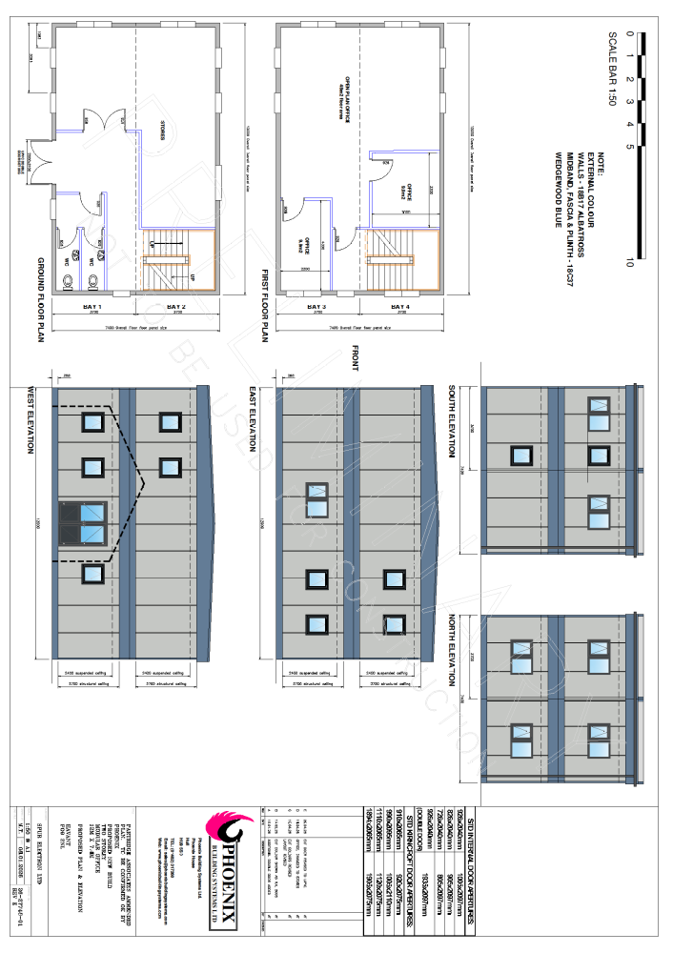
APPENDIX B
