

Construction Environmental Management Plan

For: Replacement stable barn and rationalisation of existing equestrian buildings.

At: Poundcroft Livery Stables, adjacent to 173 Havant Road, Hayling Island
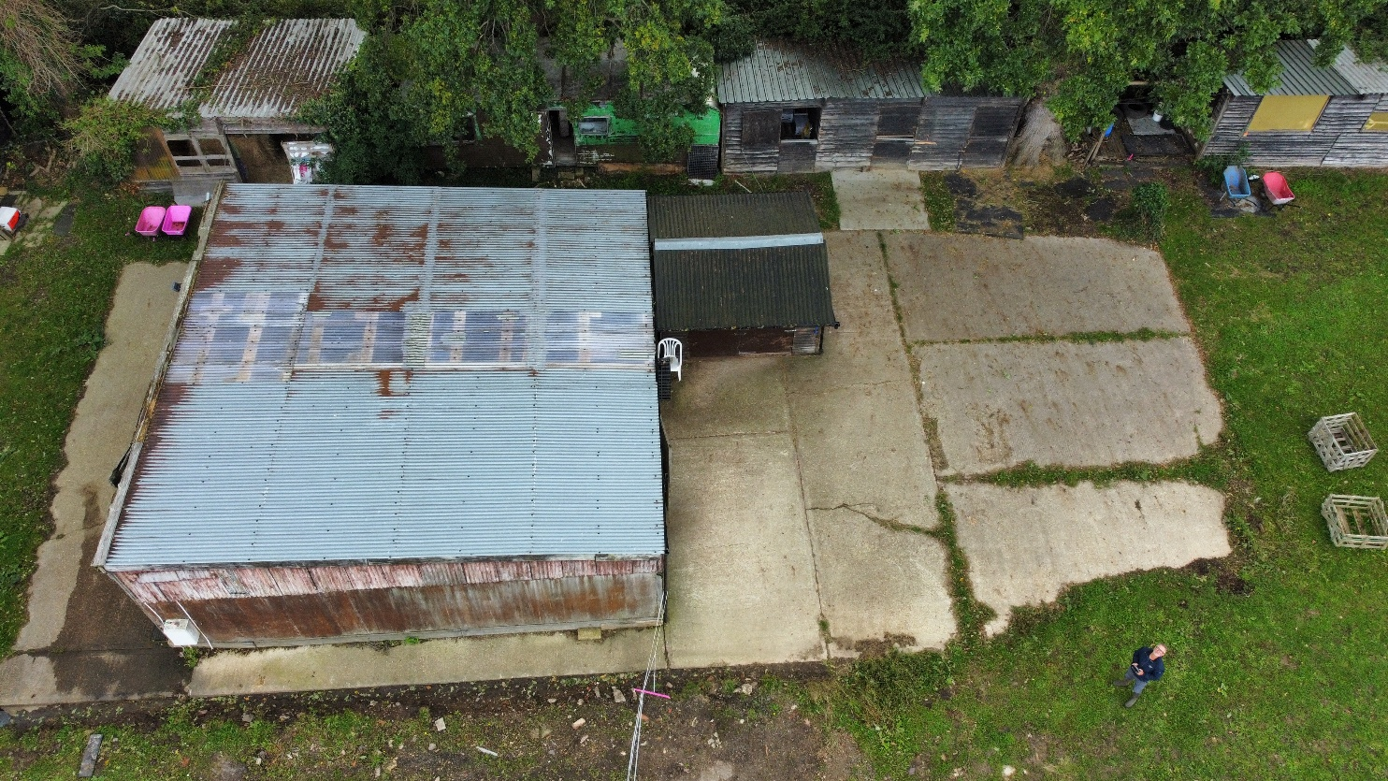
Prepared by:
Equestrian Blueprint
enquiries@equestrianblueprint.co.uk
https://equestrianblueprint.co.uk/
October 2026

1 Purpose and scope
This Construction Environmental Management Plan (CEMP) sets out measures for removing the existing equestrian barn, stables and peripheral buildings and erecting one replacement low-level barn on the existing base. The existing concrete slab will be retained. A narrow concrete strip may be required along its existing edge, approximately 0.2 metres wide by 22 metres long, giving an area of approximately 4.4 square metres. Excavation will be very limited and localised. The CEMP applies to site preparation, dismantling, local slab-edge work, deliveries, barn erection, finishing and demobilisation.
The principal ecological objective is to avoid construction noise and visual activity disturbing wintering waders and brent geese using the adjoining permanent pasture. A drainage ditch delineates and physically separates the yard from this pasture, preventing vehicle access from the construction area into the field. Construction will remain within the developed yard and existing access route. No crossing, bridging, infilling or alteration of the ditch is proposed. The pasture, ditch, retained trees and boundary vegetation will be protected throughout the works.
This CEMP is submitted in response to the Council ecologist’s recommendation for construction-phase controls. Where secured by a pre-commencement condition, written LPA approval will be obtained before development activities begin, including demolition and construction-related site preparation. The approved CEMP will be issued to contractors and retained on site throughout the works.

2 Ecological features and impact pathways
In his consultation response of 1 October 2026, Tristan Norton, Principal Ecologist, describes the application site as an existing equestrian yard with dilapidated structures and hard surfacing, of very limited ecological value. He identifies its inclusion within SWBGS Site H53A, a Secondary Support Area, and its adjacency to H53B, a Candidate (Low Use) site. He accepts that the red line area is unsuitable for wintering birds and that its inclusion is a mapping discrepancy, while the surrounding permanent pasture is suitable.
The limited slab-edge strip lies immediately alongside the existing concrete within the developed yard. It is described by the applicant as an area without ecological habitat of interest; it does not extend into the pasture or drainage ditch. Any shallow preparation will be confined to that narrow strip, with a visual check before disturbance. If unexpected habitat or wildlife is encountered, the relevant work will pause and the precautions in Section 7 will apply. The main remaining pathways are noise, visible activity, light spill, dust and polluted runoff reaching adjoining habitat.
The ecologist states that BNG is not required for this application. This CEMP addresses construction protection measures and does not substitute for the Council’s determination of the applicable BNG requirements.

3 Construction programme
Demolition and construction may take place throughout the year, subject to the controls below. The period 1 October to 31 March inclusive is treated as the sensitive wintering-bird period identified by the Council’s ecologist. High-disturbance tasks will be scheduled outside that period where practicable, but there is no commitment to April–September construction only.
Before work starts, Laura Loxton and the contractor will review the work sequence, access, storage and relationship to the adjoining pasture and confirm that the controls in this CEMP can be followed. Particular care will be taken during October–March to minimise noise and visible activity towards the fields. Routine ecological supervision is not proposed for these limited works; specialist advice will be sought if wildlife or disturbance concerns arise as set out below.

4 Responsibilities and preparation
Laura Loxton will be the nominated responsible person for implementing the ecological precautions in this CEMP. She will brief the contractor, check that works remain within the agreed yard area, undertake routine visual checks and require affected work to stop where necessary. The contractor will remain responsible for safe demolition and construction methods, plant operation and compliance by workers and delivery drivers. Laura’s role is site coordination and practical observation, rather than specialist ecological assessment.
The current application site plan will be used to identify the demolition and replacement barn area, existing access route, loading and storage areas, the local slab-edge strip and the drainage ditch separating the yard from the pasture. Laura and the contractor will agree these areas before mobilisation and mark working limits where they are not obvious. No construction compound, storage or access will extend beyond the ditch into the pasture.
Laura and the contractor will inspect the working area before mobilisation and retain the existing boundary vegetation. Trees and soft ground will be kept outside the working area, with temporary fencing or clear markers where necessary. Any conflict between safe dismantling and retained trees will be resolved before the affected work starts, obtaining arboricultural advice if needed.
Before work starts, Laura will give a short toolbox talk to the contractor and workers. It will explain that the neighbouring pasture is suitable for wintering birds; that no work, access, parking or storage is allowed there; and that noise, dust and light spill must be kept within the yard as far as practicable. It will also identify the drainage ditch as the working boundary and explain concrete and washout containment, nesting birds, unexpected wildlife and the stop-work procedure. A copy of this CEMP will be available on site and attendance recorded. New workers will receive the same briefing.

5 Working area and disturbance controls
Working hours will be 08:00–18:00 Monday to Friday and 08:00–13:00 Saturday, within daylight hours only. There will be no work on Sundays or bank holidays. Any stricter approved planning restrictions will take precedence. These hours apply to construction deliveries and loading as well as site works.
Construction parking, storage, skips, plant standing and loading will remain on existing hard surfacing within the agreed yard area. Vehicles will use the existing access from Havant Road. The drainage ditch prevents vehicle access from the yard into the pasture and will remain intact. There will be no temporary crossing, construction traffic, parking, overspill storage or pedestrian shortcut in the pasture. Activity and materials will be kept clear of the ditch banks.
Demolition will use controlled dismantling wherever safe and practical. Materials will be lowered rather than dropped and waste removed regularly. The existing slab will remain. The only possible concrete addition is the approximately 4.4 square metre strip along the existing slab edge; any shallow excavation and formwork will be restricted to this local area. Spoil will be contained within the yard and removed or reused within the authorised works. Widespread excavation, on-site crushing, piling and prolonged impact breaking are excluded. Cutting, loading and mixing will take place away from the ditch and pasture-facing edge as far as the safe layout permits. If unexpected structural requirements necessitate materially different methods, the CEMP will be reviewed and any required LPA approval obtained before the affected activity.
Plant will be suitable for the scale of work, well maintained and fitted with effective silencers. Engines will be switched off when not in use. Deliveries will be booked to avoid queuing and repeated movements. Unnecessary revving, shouting, radios and amplified music will be prohibited. Banksmen and planned vehicle movements will minimise reversing; suitable quieter alarms may be used where compatible with site safety.
Existing buildings and boundary vegetation will be used to screen activity wherever practical, with cutting, loading and plant positioned away from the pasture-facing edge. Temporary visual or local acoustic screening will be used if needed to address a particular task or an observed disturbance response, rather than installed as a blanket requirement. Any screen will be secure, non-flapping and located within the yard without harming trees or obstructing safe work.

6 Lighting habitat and pollution protection
No floodlighting or illuminated compound is proposed. Work will stop when daylight is insufficient. Any task light essential for safety will be low output, shielded and directed into the immediate work area, avoiding illumination of pasture, trees, boundary vegetation and the ditch. Lights will be switched off immediately after use. Unattended overnight lighting will not be used.
Trees and boundary vegetation will be retained. No materials, spoil, fuel or cement washings will be placed in tree protection areas, on pasture or beside the ditch. There will be no burning of waste, discharge to the ditch, or construction-related alteration of the ditch or field drainage. Any unexpected need for vegetation removal or work beyond the approved area will trigger a review before that work.
Dust will be controlled at source with careful dismantling, covered loads and limited damping down. Runoff from damping down will be contained within the work area. Dust-generating activity will stop if wind carries visible dust into adjoining habitat until an effective control is established. There will be no uncontrolled washdown into surface drains or the ditch.
Any concrete for the narrow slab-edge strip will be placed carefully, with formwork and local containment to prevent escape towards drains or the ditch. Tools, mixers and delivery equipment will not be washed out onto the ground or into drainage systems; washings will be contained and removed appropriately. Fuel and oils will be held in suitable contained storage on hardstanding away from drains and habitat. Refuelling will use a drip tray and spill materials will be accessible. Waste will be secured and removed by authorised carriers. Hazardous demolition materials will be assessed and managed by competent contractors.
Excavations will be covered or provided with an escape ramp when unattended and checked before work resumes. Pipes will be capped when stored. No dogs will be brought onto the construction site and no food waste will be left exposed.

7 Nesting birds and unexpected wildlife
Before dismantling, Laura and the contractor will check accessible parts of the affected buildings for active bird nests, including ledges and roof spaces where these can be inspected safely. Checks will take place shortly before work, with particular care during the usual March–August nesting period, and be repeated after a delay or signs of new nesting activity. Where an area cannot be checked adequately or there is uncertainty about nesting, the affected work will pause and a suitably qualified ecologist will be consulted. Active nests must be protected at any time of year.
If an active or suspected active nest is found, the affected work will stop and the nest and surrounding area will be left undisturbed. Nests will not be moved, blocked or removed. Specialist advice will be obtained where needed to establish a safe exclusion area or confirm when work can resume without affecting the nest.
Before demolition, accessible building features will also be reviewed for evidence of bats or credible roost potential. Where potential or evidence is identified, the relevant structure will not be disturbed until a suitably qualified ecologist has assessed the need for surveys, avoidance or licensing. A contractor’s visual check cannot establish the absence of bats or replace any required survey.
If bats, suspected roost evidence or other potentially protected wildlife are discovered, the affected work will stop immediately. Wildlife will not be handled, displaced or enclosed. Laura will obtain advice from a suitably qualified ecologist before the affected work resumes, with any necessary survey, licence or approval in place.

8 Monitoring stop work and completion
Laura, or a person she has briefed when she is unavailable, will check the yard boundaries and basic environmental controls at the start of each working day. During October–March, the adjoining pasture will also be viewed quietly from within the yard before starting noisy dismantling or loading and checked occasionally while these activities take place. These are practical observations of bird presence and behaviour; bird identification surveys, counts and continuous ecological monitoring are not proposed.
If birds are feeding or resting close to the working edge, Laura and the contractor will defer noisy or exposed activity at that edge and use another part of the yard, quieter methods or a later time. Workers will not enter the field, approach birds or try to move them away. The presence of birds elsewhere in the field does not automatically stop all yard activity, but the contractor will remain alert to signs of disturbance.
If nearby birds repeatedly become alert, interrupt feeding, move away or take flight in response to the works, the relevant activity will stop. Laura and the contractor will review the cause and adjust the method, location or timing, or add local screening before restarting cautiously. If disturbance recurs or effective controls are uncertain, the affected activity will remain suspended and advice will be sought from the Council’s ecologist or a suitably qualified ecological adviser. Material changes to the approved CEMP will require the necessary LPA agreement.
If there is a boundary breach, spill or dust escape towards the pasture or ditch, the relevant activity will stop and the source will be controlled before restart. Significant incidents will be recorded and reported to the applicant and relevant authority as appropriate.
Laura will retain the approved CEMP, the site plan, contractor contacts and toolbox talk record. A brief site note will record the start-of-day checks and any wildlife concern, incident, pause or change to working methods. Detailed bird survey logs and routine ecological reports are not required under this method.
At completion, waste, plant and temporary facilities will be removed without entering the pasture. Laura and the contractor will check that adjoining vegetation, the field edge and ditch remain undamaged, and record any necessary remedial action.

9 Implementation records
Laura Loxton is the nominated responsible person for this CEMP. Before mobilisation she will record the contractor’s name, site contact and telephone number, her own contact details, and the intended work dates in the site file. These details will be available to the contractor and workers throughout the works.
The site file will also contain the current application site plan, the approved CEMP and the LPA’s approval reference when issued. Laura will record the toolbox talk date and attendees before work begins. These implementation records will be maintained on site and made available to the LPA on request.

10 References
Tristan Norton, Principal Ecologist, Havant Borough Council: consultation response to Jennie Fox dated 1 October 2026, APP/26/00624.
Current application site plan and planning conditions for APP/26/00624.
Natural England and Defra: Wild birds protection and licences; Bats protection and licences. GOV.UK guidance consulted 12 October 2026.
www.gov.uk/guidance/wild-birds-protection-surveys-and-licences
www.gov.uk/guidance/bats-protection-surveys-and-licences

