

Tree Protection Plan

For: Replacement stable barn and rationalisation of existing equestrian buildings.

At: Poundcroft Livery Stables, adjacent to 173 Havant Road, Hayling Island
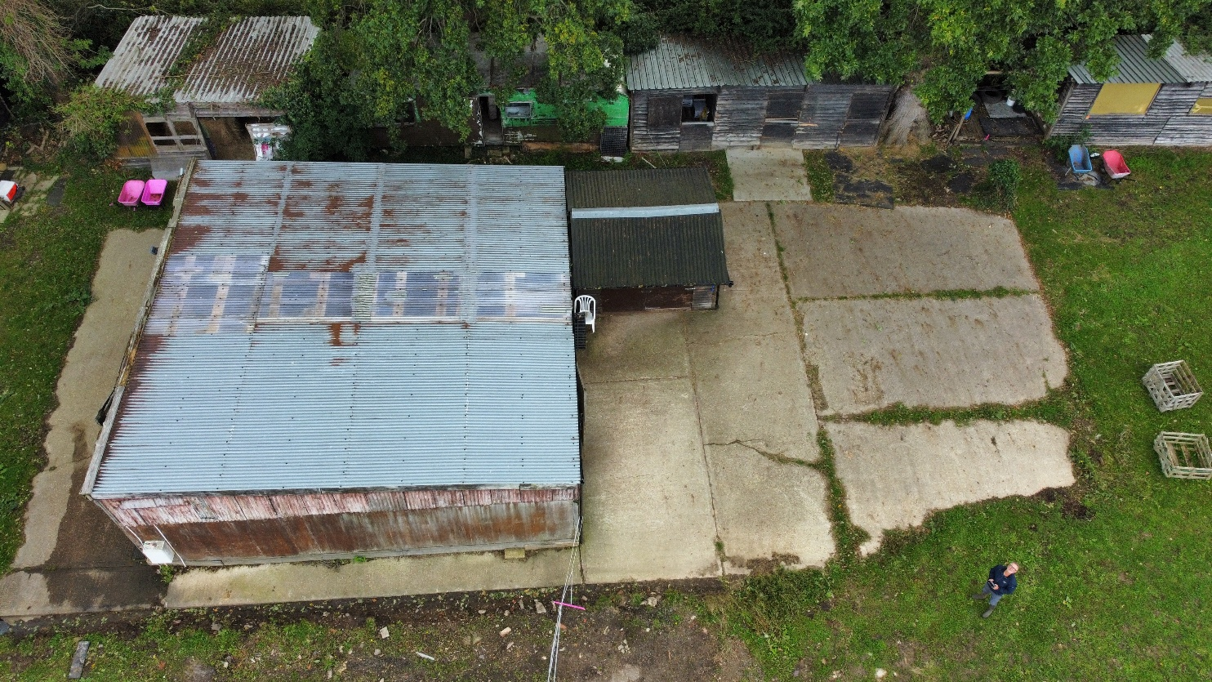
Prepared by:
Equestrian Blueprint
enquiries@equestrianblueprint.co.uk
https://equestrianblueprint.co.uk/
October 2026

Works and protection approach
All trees are retained and no pruning is anticipated. The existing main concrete slab remains intact, existing pipework is reused and no new service trenches are proposed. The replacement is a sectional timber building, erected principally by hand by the applicant, partner or family, with only limited use of a very small machine.
Before dismantling, install Heras protection fencing to separate the southern tree belt and adjoining exposed rooting soil from the working area. Position fencing along the outer edge of the protected southern route, with returns preventing access around its ends. Protect exposed rooting soil around the access-side birch and other retained trees affected by site operations. Read these measures with the accompanying tree protection drawing and BS fencing detail. Dismantle progressively from the top down and lower/direct components inward onto the existing slab. Keep debris on the slab and remove it by the existing access. Keep machinery on suitable retained hard surfaces; prevent contact with trunks or overhanging branches. Use the retained hard surfaces for deliveries, parking and material storage in accordance with CEMP1, maintaining the tree protection measures throughout.

Heras fencing
Use approximately 2 m high rigid welded-mesh Heras panels, securely joined, braced and stabilised in accordance with the BS 5837 fencing detail accompanying the final submission. Use surface-supported feet/bracing where possible to avoid penetrating rooting soil. Do not attach anything to trees. Display "TREE PROTECTION AREA - KEEP OUT" signs. Install before works and retain until materials and equipment are removed. Check daily and reinstate any displaced panel before continuing. See Figure 2 and 3.
Behind the fence: no access, storage, parking, spoil, mixing, washout or changes in ground level. Fencing protects exposed rooting soil; the indicative RPA circles also extend beneath existing buildings and hard surfaces. Those surfaces are retained and used with care, rather than assumed to exclude roots.

GP1 - temporary ground protection for dismantling and small tracked machinery
Provide temporary ground protection along the south of the retained concrete base before dismantling starts. It will protect the adjoining rooting soil from dismantling activity and, if required, provide a route for a small tracked machine excavating the optional concrete strip. Protect any other unsurfaced ground within the rooting areas that must be used during dismantling before that use. Keep arisings on retained concrete or remove them promptly; do not use protected soil as a debris stockpile.
Lay a permeable geotextile over the existing ground without excavation, soil stripping or levelling, with a compression-resistant cushioning layer and proprietary interlinked load-spreading trackway mats above. Select the complete system for the actual tracked machine, its fully equipped operating weight, ground bearing conditions and working loads. A nominal 150 mm woodchip cushioning layer may form part of the system where appropriate, subject to the supplier's specification; this thickness alone does not establish suitability for a tracked excavator. Scaffold boards alone are not an adequate machine trackway.
The protected strip must accommodate the full track width with the clearance required by the supplier, and all intended movements and working positions. Set the route width and fence position to those requirements before use. Install from retained concrete or already protected ground, keep every track fully on the mats and prevent turning, slewing or excavating from loading unprotected soil. Extend protection to any necessary entry or exit point. Use the smallest practicable machine; do not permit access if the system is unsuitable or if it sinks, shifts or exposes soil. Keep Heras fencing on the outer edge of the protected route. Maintain throughout dismantling and any machine use, then remove carefully without scraping the soil.

Possible southern concrete strip
A bespoke building may avoid any slab extension. If required, limit the southern addition to approximately 200 mm x 22 m and excavation to approximately 150 mm. Carefully excavate in shallow increments by hand or with a very small machine using a non-toothed bucket, operating from the retained slab or the specified load-rated GP1 route. Do not rake, drag or wrench through the soil. Stop machine excavation immediately if roots are exposed; leave them intact and seek advice before proceeding. Do not cut or encase roots in concrete. Contain wet concrete and washings. Adjust protection locally only as necessary to excavate the 200 mm strip; retain protection beneath the machine and keep the adjoining soil fenced off. Reinstate protection promptly afterwards.

Indicative root protection areas
For a single stem, radius = 12 x trunk diameter, capped at 15 m. Figures below use the supplied plan diameters as working values. They are circular planning zones, not surveyed root extents. No reduction has been made because of existing concrete. The topo does not record the measurement height, so these are indicative BS 5837-based calculations rather than a certified arboricultural survey. See drawing TP1.
Reference / location | Diameter used | RPA radius
T1 Oak, west end of main barn | 1.10 m, single stem | 13.20 m
T2 Oak, central southern boundary | 0.80 m, single stem | 9.60 m
T3 Ash, west of storage building | 1.30 m adopted | 15.00 m (cap)
T4 Oak, east of storage building | 0.80 m, single stem | 9.60 m
T5 Silver birch, beside access | 0.20 m / 2 stems* | 3.40 m*
T6 Western oak, topo 1.1 / 1T | 1.10 m, single stem | 13.20 m

Root protection areas for multi-stem trees are based on assumptions drawn from the survey annotations. A radius of 3.40 m has been adopted for T5, assuming two stems each 0.20 m in diameter. The exposed rooting ground around the other multi-stem trees will be protected within the fenced areas.

Implementation and completion
The applicant or person supervising the work will brief everyone involved on these measures before dismantling starts, photograph the installed protection and check it daily. Keep fencing and ground protection in place throughout dismantling and construction. If roots are exposed, tree damage occurs, or additional excavation or pruning becomes necessary, stop work in that area and obtain appropriate arboricultural advice before proceeding. Routine arboricultural attendance is not required by these measures. Remove protection only after construction equipment and materials are cleared, without disturbing the underlying soil.

