

Toolbox Talk

For: Replacement stable barn and rationalisation of existing equestrian buildings.

At: Poundcroft Livery Stables, adjacent to 173 Havant Road, Hayling Island
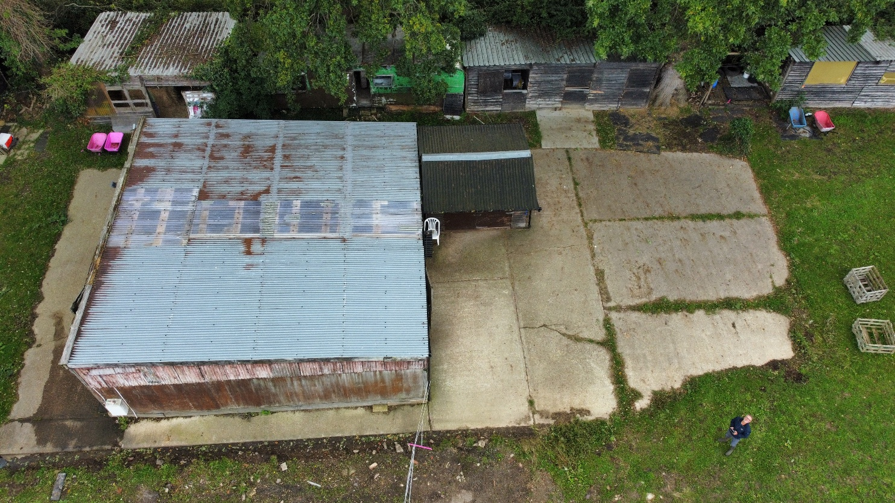
Prepared by:
Equestrian Blueprint
enquiries@equestrianblueprint.co.uk
https://equestrianblueprint.co.uk/
October 2026

Environmental toolbox talk
To be delivered by Laura Loxton before work starts and to each new worker. Use the site plan to point out the working limits, access, storage areas, slab edge and ditch. Keep this talk and the attendance record with the approved CEMP on site. Follow any stricter planning restrictions. Where required, CEMP approval must be in place before demolition or site preparation begins.

1. Stay within the agreed area
All work, deliveries, parking, skips, plant and materials must stay within the agreed area and existing hardstanding. Use the existing access from Havant Road.
The ditch separates the yard from pasture used by wintering birds and prevents vehicle access to that field. Do not cross, bridge, infill or alter it. No pedestrian shortcuts, parking, storage or works in the pasture. Keep ditch banks clear. Retain trees and boundary vegetation; respect marked protection areas.
Retain the existing concrete slab. The only possible addition is a strip approximately 0.2 m × 22 m (4.4 m²) along its edge. Check this strip visually before disturbance; keep excavation, formwork and spoil local and within the yard. No widespread excavation, crushing, piling or prolonged impact breaking. Tell Laura before any change in scope or method.

2. Keep noise and visible activity down
Work and deliveries: 08:00–18:00 Monday–Friday; 08:00–13:00 Saturday, in daylight only. No Sundays or bank holidays. Stop when daylight is insufficient.
Dismantle carefully where safe; lower materials rather than dropping them. Position cutting, mixing, loading and plant away from the pasture edge and ditch where safe. Use existing buildings and vegetation as screening. Laura will arrange secure, non-flapping local screening if needed.
Switch off idle engines. No unnecessary revving, shouting, radios or amplified music. Plan deliveries and vehicle movements to avoid queuing and unnecessary reversing; retain all necessary safety measures. No floodlighting or overnight lighting. Essential safety task lights must be low output, shielded, directed into the work area and switched off after use.

3. Extra care for wintering birds: 1 October–31 March
Laura, or her briefed replacement, will quietly view the pasture from the yard before noisy dismantling or loading and check occasionally during those activities. Schedule high-disturbance tasks outside this period where practicable.
If birds are feeding or resting close to the working edge, defer noisy or exposed work there: use another yard area, quieter methods or a later time. Never approach or move birds. Birds elsewhere in the field do not automatically stop all yard activity.
If nearby birds repeatedly become alert, stop feeding, move away or take flight in response to work: STOP the relevant activity and tell Laura. Adjust method, location, timing or screening before restarting cautiously. If disturbance recurs or controls are uncertain, keep that activity stopped and obtain ecological advice.

Protect habitat • Stop and report

4. Prevent dust, spills and polluted runoff
Control dust at source; cover loads and use limited damping down with runoff contained. Stop dust-generating work if visible dust blows into adjoining habitat until effective controls are in place.
Contain concrete using formwork and local protection. Prevent concrete spills and uncontrolled discharge of cement washings, dirty water, fuel or oil onto the ground or into drains or the ditch. Contain and remove all tool, mixer and delivery-equipment washings appropriately.
Store fuel and oils in contained storage on hardstanding away from drains and habitat. Use drip trays for refuelling and know where spill materials are kept. Stop and contain any spill, dust escape or boundary breach; report it to Laura before restarting. Secure waste for authorised removal; no burning.
Cover unattended excavations or provide an escape ramp; check before restarting. Cap stored pipes. No dogs on the construction site and no exposed food waste.

5. Check before dismantling; leave wildlife undisturbed
Laura and the contractor will check safely accessible ledges, roof spaces and other affected building parts shortly before dismantling for active nests. Take particular care March–August, repeat checks after delays or new nesting activity, and protect active nests at any time of year. If checks are inadequate or uncertain, pause the affected work for ecological advice.
Before demolition, review accessible building features for bat evidence or credible roost potential. Where either is identified, do not disturb the structure until a qualified ecologist has assessed what is needed. A visual check cannot confirm absence of bats or replace a required survey.
If an active or suspected active nest, bat, suspected roost evidence or other potentially protected wildlife is found: STOP affected work immediately, leave the area undisturbed and tell Laura. Do not handle, displace or enclose wildlife; do not move, block or remove nests. Laura will obtain advice as needed and confirm when work may safely resume, with any necessary surveys, licence or approval in place.

6. Daily checks and who to contact
Laura (or her briefed replacement) checks boundaries and environmental controls at the start of each day. Keep a brief note of checks, incidents, wildlife concerns, pauses and changes. At completion, remove temporary facilities and waste from within the yard; check the vegetation, ditch and field edge for damage.
Laura coordinates these precautions; the contractor remains responsible for safe working. Routine ecological supervision, bird counts and detailed survey logs are not required by this CEMP. Seek specialist advice where the stop-work triggers above apply. Material changes to the approved CEMP require the necessary LPA agreement.
Laura / nominated replacement telephone: __________________________
Contractor / site contact and telephone: ____________________________

