PLANNING APPLICATION RESPONSE OF PLANNING POLICY

Application No: | APP/26/00615
Site Address: | Land North of Lavant Drive
Development: | Construction of an 86-bed care home (within Class C2) with access, car parking, landscaping and associated works
Case Officer: | Jennie Fox
Comments by: | Jade Ellis
Date of Comments: | 13th October 2026

Policy Status:

The Local Plan (Core Strategy) and the Local Plan (Allocations), together with the Hampshire Minerals and Waste Plan, provide the development plan for the borough.

Public consultation on the Council’s Publication Building a Better Future Plan concluded on 9th September 2026. This has limited weight in decision making at this stage.
These documents are available at www.havant.gov.uk/localplan.

Principle of Development:

The site lies within the urban area as defined by Policies CS17 and AL2 of the Development, or within the ‘Settlement’ for the purposes of the 2026 NPPF. NPPF Policy S3(1)(a) provides a presumption in favour of sustainable development within settlements and indicates that Policy S4 would be applicable.

Policy S4(1) indicates that development proposals within settlements should be approved unless the benefits of doing so would be substantially outweighed by any adverse effects, when assessed against the national decision-making policies in the Framework. Policy S4(2) goes on to set out circumstances in which benefits of approving development are likely to be substantially outweighed by adverse effects.

Given the site forms part of a mixed use allocation including housing (90 dwellings), care home and community health uses under site reference H69 in Policy HB3 of the Allocations Plan, Policy S4(2)(a)(i) would be relevant if the proposals would have a substantial adverse impact in relation to the allocation for the particular uses in the development plan. This is not the case here, as the proposal would deliver at least part of the uses envisaged in the allocation.

The Publication Building a Better Future Plan proposes to retain the site as an allocation (reference 7, SHELAA references HA09 & HA10) for a 90 bed care home and 21 homes. Though it is noted that HA09 to which this application relates was promoted for 21 dwellings through the Council’s Call for Sites by NHS Property Services, whilst HA10 – the land to the north and east of the site was previously promoted for a 100 bed care home and 60 extra units by Hampshire County Council. The Council’s SHELAA notes that Hampshire County Council’s Regulation 18 consultation response in 2025 confirms the site is surplus to operation needs and is currently reviewing its planning and disposal strategy for the site.
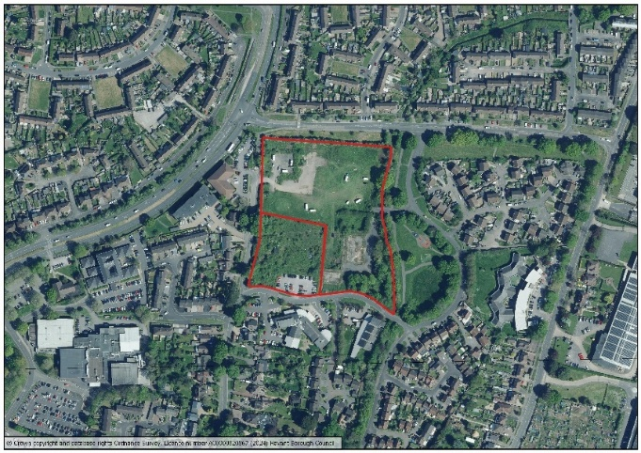
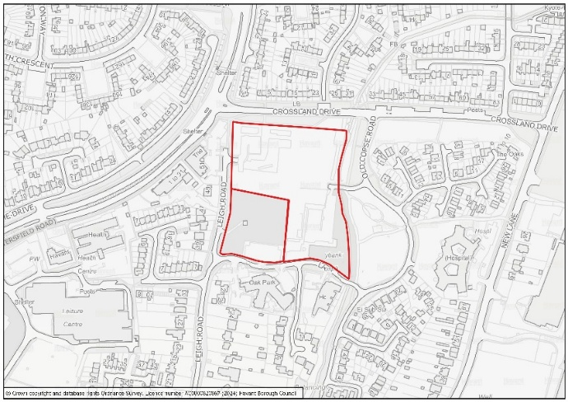

Whilst the allocation in the emerging Local Plan envisaged the delivery of a care home on the wider site to the north and east, there would be no objection to the proposed care home on this part of the site.

Coordination of Development:

As set out above, the site forms part of the mixed use allocation for housing, care home and community health uses on the Former Oak Park School site reference H69. As noted above, the application site forms one of two landownerships – with the land to the north and east of the site owned by Hampshire County Council being promoted separately for older persons’ housing.

As such, it should be demonstrated that development would not undermine the future development of the adjacent site in separate ownership in accordance with Core Strategy Policy DM6. It is noted that an indicative layout masterplan for the adjacent site has also been submitted with the application which shows how development could be delivered on the remainder of the allocation. It is noted that the application site would function in isolation from the wider site, but that this would also reflect the nature of the development with the need for security for the care home and its residents.

Parking:

The proposals would need to ensure that appropriate parking provision is provided in accordance with Policy DM13 and the Council’s Parking SPD. For sheltered housing, the notes under Table 4C of the Parking SPD are of relevance:

3. Given the broad range of accommodation available and the varying needs of occupants the Council will consider the parking requirements of older people’ housing on a case by case basis and will require a full assessment of individual needs to be submitted in the Design and Access Statement, Transport Assessment or other supporting information.

4. The assessment should be based on parking provision and parking need and should demonstrate how and where parking needs will be met throughout a 24 hour period. The performance of a comparable development should be provided where practicable. The following should also be provided in respect of the proposed development and any comparable development informing the proposal:

The Planning Statement indicates the proposal includes provision for 27 parking spaces, including two designated accessible bays for visitors and staff and a dedicated ambulance drop-off area.

It is noted that Table 6-3 of the submitted Transport Assessment assesses car parking demand from comparable car home developments. Paragraph 6.4.2 notes that the assessment identified that up to 16 cars can be expected to park at any one time associated with the proposed development, or 59% of the proposed car parking for the development.

Five year housing land supply:

The Council’s Five Year Housing Land Supply Update (December 2025) indicates the Council has 1.3 years supply with a 20% buffer applied. This is below the five year supply threshold.

The site is not currently included in the five-year housing land supply position in whole or part. The PPG indicates that authorities are able to count housing provided for older people against their housing requirement, which is calculated on the average number of adults living in households, using published data. For example, an 86 bed care home would be equivalent to 45.3 dwellings (86 beds divided by 1.9 persons). As such, the development would have the potential to make a modest contribution to boost five year land supply which should be afforded weight in the planning balance.

Summary:

The development proposals would secure the redevelopment of a brownfield site within the settlement. As such, there would be a presumption in favour of sustainable development unless the benefits of doing so would be substantially outweighed by any adverse effects, when assessed against the national decision-making policies in the Framework.

Furthermore, the Council is not currently able to demonstrate an up-to-date five-year housing land supply. The proposals would contribute to increasing the Council’s land supply in the short term, this must be afforded weight.

